MINI PROJECT

(SESSION-2020-2021)

**Edu_Hub: A Hub of Knowledge**

Report



**Institute of Engineering & Technology**

**Team Members**

**AKSHAT SINHA**

**(181500063)**

**AMAN SAXENA**

**(181500077)**

**AKARSHIT SRIVASTAVA**

**(181500056)**

**HARSHIT SAXENA**

**(181500258)**

**VARUN SAXENA**

**(181500783)**

## Supervised By

**MR. ANAND GUPTA**

**MRS. RUCHI GUPTA**

**TECHNICAL TRAINERS**

**Department of Computer Engineering & Application**



**Department of Computer Engineering and Applications**

**GLA University, Mathura**

**17 km. Stone NH#2, Mathura-Delhi Road, P.O. – Chaumuha,**

**Mathura – 281406**

**-**

**DECLARATION**

I hereby declare that the work which is being presented in the Mini Project **“Edu_Hub”,** in partial fulfillment of the requirements for Mini project Lab is an authentic record of our own work carried under the supervision of **Mr. Anand Gupta and Mrs. Ruchi Gupta, Technical Trainers.**

**Team Members**

Akshat Kumar Sinha

Aman Saxena

Akarshit Srivastava

Harshit Saxena

Varun Saxena



**Department of Computer Engineering and Applications**

**GLA University, Mathura**

**17 km. Stone NH#2, Mathura-Delhi Road, P.O. – Chaumuha,**

**Certificate**

This is to certify that the project entitled “Edu_Hub” carried out in Mini Project – I Lab is a Bonafede work done by Akshat Kumar Sinha (181500063), Aman Saxena (181500077), Akarshit Srivastava (181500056), Harshit Saxena (181500258) and Varun Saxena (181500783) is submitted in partial fulfillment of the requirements for the award of the degree Bachelor of Technology (Computer Science & Engineering).

Signature of Supervisor:

Name of Supervisor: Mr. Anand Gupta and Mrs. Ruchi Gupta

Date: 20/11/2020

**ACKNOWLEDGEMENT**

It gives us a great sense of pleasure to present the report of the B. Tech Mini Project undertaken during B. Tech. Third Year. This project in itself is an acknowledgement to the inspiration, drive and technical assistance contributed to it by many feedbacks. This project would never have seen the light of the day without the help and guidance that we have received.

Our heartiest thanks to Dr. (Prof). Anand Singh Jalal, Head of Dept., Department of CEA for providing us with an encouraging platform to develop this project, which thus helped us in shaping our abilities towards a constructive goal.

We owe special debt of gratitude to Mr. Anand Gupta and Mrs. Ruchi Gupta, Technical Trainers, for their constant support and guidance throughout the course of our work. Their sincerity, thoroughness and perseverance have been a constant source of inspiration for us. They have showered us with all their extensively experienced ideas and insightful comments at virtually all stages of the project & has also taught us about the latest industry-oriented technologies.

We also do not like to miss the opportunity to acknowledge the contribution of all faculty members of the department for their kind guidance and cooperation during the development of our project. Last but not the least, we acknowledge our friends for their contribution in the completion of the project.

**Abstract**

In today’s time, students want to learn new technologies and excel in their college academics for a better carrier and future. Now, if a student couldn’t attend his/her classes, they certainly search the internet for notes and concept clearance. Now, they literally waste their 25-30 minutes searching for a particular topic on Google, trying to find the perfect link. So, we claim that our website, ‘Edu_hub’ will certainly solve this problem by providing a platform to students where they can find notes of subjects from class 9 -12. Specially for GLA University students, we will provide subject notes of all CSE subjects of First year to Final year. There will be YouTube links for various coding and educational videos, and some motivational videos for students who sometimes feel low due to their academic pressures. The scope of this Project is to provide a complete package of resources to students who are interested in CSE domain and want to nurture their skills from an early stage.

Since our target audience are the students itself, so our website could be proved to be very helpful for the overall academic balance of the young minds. We believe that our small project could extend into a major product with the help of number of students visiting and using our website. According to the new Educational Reform Policy of India, students will be learning coding from class 6th onwards. So, it’s clear that programming is going to be the new normal for coping with the future technologies. So, our website could help students to develop interest in CS and inculcate the programmer in them.

**Table of Contents**

Declaration 2

Certificate 3

Acknowledgement 4

Abstract 5

Table of contents 6

**1.Introduction 7**

1.1 General Introduction to the topic 7-8

1.2 Area of Computer Science 8

1.3 Objective 9

1.4 Implementation details 9

1.5 Future Scope 10

1.6 Contribution the project would make 10

1.7 Hardware/Software requirements 10-18

**2.Software Requirement Analysis 18**

2.1 Problem definition 18

2.2 Development tools 18-20

**3.Software Design 21-22**

**4.Implementation and user interface 23-53**

**5.References/Bibliography 54**

**1)Introduction**

**1.1 General Introduction to the Topic**

So basically, Edu_hub is an Educational dynamic website which will help students to have all the study materials and related stuffs in one place to help them through their academic life. We are building a Web browser-based application which will be responsive as well so that students can access our provided content on their smart phones too.

**Special advantage for GLA university students**

We have a special section for the students of GLA University CSE department so that they could be endowed with various notes and video lectures to help them with their academics. The site will also provide the students with previous year papers to help them tackle the exam pressure and so their preparation could be perfect. As this website is being developed by the students of GLA University, we will have special sections regarding various events and notices of the University so that students could feel that this site is particularly being developed for them.

**Class 9th to 12th**

This site also boosts its wide presence of study materials for the students of class 9 to 12 respectively. Our main focus is to imbibe an interest in Computer Science to the students at an early age so that they could feel confident for the vast scope in Computer Science field. Notes and PDF will be provided at an easy accessibility rate to the students.

**Competitive Exams**

Study materials will be provided for various Competitive exams like IIT-JEE and SAT for the best preparation of students for tackling these highly competitive exams.

**Blogs**

We will also add a blog section in our website where people having knowledge about challenging topics like AI, ML etc. can post their experiences and interact with the students for a healthy and fruitful discussions. The site will have an attractive newsfeed regarding various articles of Technology related issues so as to keep our Target audience well updated with the future in this domain.

So, in a nutshell, the scope of this Project is to provide a complete package of resources to students who are interested in CSE domain and want to nurture their skills from an early stage.

**1.2 Area of Computer Science**

Our Project is centered on students from class 9 to CSE domain. It will provide various notes and resources to learn and take the pressure off of academics. It could be used as a helpful tool to utilize time, as in the current situation, students intend to clear their concepts by searching for their content on various search engines but end up getting their time and energy wasted. We would provide all the links and resources at one destination, so that students wouldn’t have to wastes their time looking for study materials all over the web.

Since our target audience are the students itself, so our website could be proved to be very helpful for the overall academic balance of the young minds.

Companies, Organizations and their users are now aware of the importance of strong internet presence. Educational websites are every company’s virtual identification. And they are the first impression of any educational institution. The importance of educational websites is so vast that we have to be certain that the information submitted is accurate. So, there is always a chance that students will prefer these sites over others in the field.

The online learning form is best suited for anybody. The digital revolution has led to profound improvements in how to view, consume, analyze, and share content. Like teaching in the classroom, users can access the content an infinite number of times using online learning.

This is particularly required when preparing for an exam at the time of revision. A major advantage of e-learning is that it ensures the students that they are in sync with modern learners. It helps the learner to access new material whenever he wants. e-Learning is a way to offer the lessons quickly. E-Learning helps to create and share new training, strategies, ideas, and concepts.

Whether it’s for formal training or entertainment, e-Learning is a very quick way to learn. It allows teachers to get a higher degree of visibility and reliably while conveying messages to their target audience. It means that all learners with this learning style undergo the same kind of instruction.

Compared to traditional forms of learning e-Learning is cost-efficient. The explanation for this price decrease is that learning through this mode happens fast and easily.

**1.3 OBJECTIVE**

The main objective of the Project is to provide a platform where Engineering students get all the information(notes) of the particular subject, instead of wandering on many different sites over Internet. This will reduce their time of searching and help them over their studies.

We will also provide the pdf of all practice sheets which are provided by the teachers in their classes and ppts which are made by teachers(lecturers).

We believe that the Internet should not only be a place for Entertainment and social media, but also be used as a tool to enhance one’s skills and excel in their academics.

Reason for choosing this topic is to provide a platform to students where they can find all the resources relating to their respective CS domain. We are building a Web browser-based application which will be responsive as well so that students can access our provided content on their smart phones too.

**1.4 Implementation details**

Implementation details were as follows:

1) Firstly, we completed Home page and all the pages of the website which is visible to the user through Frontend Technologies. The pages are clear and attractive and responsive to the users.

We added different sections in the navigation bar regarding different subjects, so we have having pages for each section respectively. In each page, there are precise content about the topics with various YouTube links for a clear description of concept.

2) After the completion of all the Frontend related stuff, we moved to work on the backend and database part of our website. The search bar was made using Php and MySQL respectively.

3) Lastly, we provided a final touch to our Project with Login and Signup pages which serves as a welcoming page to our users.

**1.5 FUTURE SCOPE:**

The future scope of this Project is to add links of video lectures for each and every topic of CS Domain as it will help the students in understanding the topics clearly and precisely.

Only authenticated users will be able to access our materials in the future. We will keep them updated with our new updates and notifications.

We will also add motivational videos to boost up the self-confidence of the students.

We will also add a blog section in our website where people having knowledge about challenging topics like AI, ML etc. can post their experiences and interact with the students for a healthy and fruitful discussions.

The site will have an attractive newsfeed regarding various articles of Technology related issues so as to keep our Target audience well updated with the future in this domain.

Only authenticated users will be able to access our content

So, in a nutshell, the scope of this Project is to provide a complete package of resources to students who are interested in CSE domain and want to nurture their skills from an early stage.

**1.6 CONTRIBUTION THE PROJECT WOULD MAKE:**

Our Project is centered on students from class 9 to CSE domain. It will provide various notes and resources to learn and take the pressure off of academics. It could be used as a helpful tool to utilize time, as in the current situation, students intend to clear their concepts by searching for their content on various search engines but end up getting their time and energy wasted. We would provide all the links and resources at one destination, so that students wouldn’t have to wastes their time looking for study materials all over the web.

Since our target audience are the students itself, so our website could be proved to be very helpful for the overall academic balance of the young minds.

**1.7 Hardware and Software used**

**Hardware requirements**

* + Laptop/Desktop
  + 1.8 GHz or faster processor. Quad-core or better recommended
  + 2 GB of RAM
  + Hard disk space: Minimum of 800MB up to 210GB of available space
  + Video card that supports a minimum display resolution of 720p (1280 by 720)

**Software used**

**Frontend Technologies:**

***1. HTML5***

***2. CSS3***

***3. JavaScript***

***4. Bootstrap4***

**HTML5**

**Hypertext Markup Language** (**HTML**) is the standard markup language for creating web pages and web application. With Cascading Style Sheets (CSS) and JavaScript, it forms a triad of cornerstone technologies for the World Wide Web.

Web Browser receive HTML documents from a web server or from local storage and render the documents into multimedia web pages. HTML describes the structure of a web page semantically and originally included cues for the appearance of the document.

HTML Elements are the building blocks of HTML pages. With HTML constructs, images and other objects such as interactive forms may be embedded into the rendered page. HTML provides a means to create structured documents by denoting structural semantics for text such as headings, paragraphs, lists, links, quotes and other items. HTML elements are delineated by *tags*, written using angle brackets. Tags such as <img/> and <input/>directly introduce content into the page. Other tags such as <p> surround and provide information about document text and may include other tags as sub-elements. Browsers do not display the HTML tags, but use them to interpret the content of the page.

HTML can embed programs written in a scripting language such as JavaScript, which affects the behavior and content of web pages. Inclusion of CSS defines the look and layout of content. The World Wide Web Consortium (W3C), maintainer of both the HTML and the CSS standards, has encouraged the use of CSS over explicit presentational HTML since 1997

HTML code ensures the proper formatting of text and images so that your browser may display them as they are intended to look. Without HTML, a browser would not know how to display text as elements or load images or other elements. HTML also provides a basic structure of the page, upon which [Cascading Style Sheets](https://www.computerhope.com/jargon/c/css.htm) are overlaid to change its appearance. One could think of HTML as the bones (structure) of a web page, and CSS as its skin (appearance).

*Advantages of HTML*

1. HTML is easy to use and understand

2. All browsers support HTML

3. HTML and XML syntax is very similar

4. It is free to use

5. Most development tools support Html.

6. Html is most search engine friendly

**CSS3**

**C**ascading **S**tyle **S**heets, fondly referred to as CSS, is a simple design language intended to simplify the process of making web pages presentable.

CSS handles the look and feel part of a web page. Using CSS, you can control the color of the text, the style of fonts, the spacing between paragraphs, how columns are sized and laid out, what background images or colors are used, layout designs, variations in display for different devices and screen sizes as well as a variety of other effects.

CSS is easy to learn and understand but it provides powerful control over the presentation of an HTML document. Most commonly, CSS is combined with the markup languages HTML or XHTML.

There are three types of CSS which are given below:

1) Inline CSS

2.) Internal or Embedded CSS

3.) External CSS

Inline CSS: Inline CSS contains the CSS property in the body section attached with element is known as inline CSS. This kind of style is specified within an HTML tag using the style attribute.

Internal or Embedded CSS: This can be used when a single HTML document must be styled uniquely. The CSS rule set should be within the HTML file in the head section i.e. the CSS is embedded within the HTML file.

External CSS: External CSS contains separate CSS file which contains only style property with the help of tag attributes (For example class, id, heading etc. CSS property written in a separate file with .css extension and should be linked to the HTML document using link tag. This means that for each element, style can be set only once and that will be applied across web pages.

Properties of CSS: Inline CSS has the highest priority, then comes Internal/Embedded followed by External CSS which has the least priority. Multiple style sheets can be defined on one page. If for an HTML tag, styles are defined in multiple style sheets then the below order will be followed.

As Inline has the highest priority, any styles that are defined in the internal and external style sheets are overridden by Inline styles.

Internal or Embedded stands second in the priority list and overrides the styles in the external style sheet.

External style sheets have the least priority. If there are no styles defined either in inline or internal style sheet then external style sheet rules are applied for the HTML tags.

**Advantage Of CSS**

**CSS saves time** − You can write CSS once and then reuse same sheet in multiple HTML pages. You can define a style for each HTML element and apply it to as many Web pages as you want.

**Pages load faster** − If you are using CSS, you do not need to write HTML tag attributes every time. Just write one CSS rule of a tag and apply it to all the occurrences of that tag. So, less code means faster download times.

**Easy maintenance** − To make a global change, simply change the style, and all elements in all the web pages will be updated automatically.

**Superior styles to HTML** − CSS have a much wider array of attributes than HTML, so you can give a far better look to your HTML page in comparison to HTML attributes.

**Multiple Device Compatibility** − Style sheets allow content to be optimized for more than one type of device. By using the same HTML document, different versions of a website can be presented for handheld devices such as PDAs and cell phones or for printing

**Global web standards** − Now HTML attributes are being deprecated and it is being recommended to use CSS. So, it’s a good idea to start using CSS in all the HTML pages to make them compatible to future browsers.

**JavaScript**

JavaScript is a lightweight, cross-platform and interpreted scripting language. It is well-known for the development of web pages; many non-browser environments also use it. JavaScript can be used for Client-side developments as well as Server-side developments. It is used to add interactivity to our pages. With just a basic understanding of the language, we can create a page that will react to common events such as page loads, mouse clicks & movements, and even keyboard input.

JavaScript is the most popular language on earth.

With advances in browser technology and JavaScript having moved into the server with Node.js and other frameworks, JavaScript is capable of so much more.

Here are a few things that we can do with JavaScript:

1)JavaScript was created in the first place for DOM manipulation. Earlier websites were mostly static, after JS was created dynamic Web sites were made.

2)Functions in JS are objects. They may have properties and methods just like another object. They can be passed as arguments in other functions.

3)Can handle date and time.

4)Performs Form Validation although the forms are created using HTML.

5)No compiler needed.

**Bootstrap4**

Bootstrap is a free and open front-end framework for designing websites and web applications. It contains HTML - and CSS -based design templates for typography, forms, buttons, navigation and other interface components, as well as optional JavaScript extensions. Unlike many earlier web frameworks, it concerns itself with front end development only.

Bootstrap is the second most-starred project on GitHub, with more than 129,000 stars. Bootstrap comes with several JavaScript components in the form of jQuery plugins. They provide additional user interface elements such as dialog boxes, tooltips, and carousels. They also extend the functionality of some existing interface elements, including for example an auto-complete function for input fields. In version 1.3, the following JavaScript plugins are supported: Modal, Dropdown, Scroll spy, Tab, Tooltip, Popover, Alert, Button, Collapse, Carousel and Typeahead.

Bootstrap is available in two forms; as a precompiled version, and as a source code version. The source code version uses the [Less](http://lesscss.org/) CSS preprocessor, but if you are more into Sass, there is an [official Sass port of Bootstrap](https://github.com/twbs/bootstrap-sass) also available. To make it easier to make use of CSS vendor prefixes, Bootstrap uses [Autoprefixer](https://github.com/postcss/autoprefixer).

The source code version comes styles source code written in Less (or Sass), all the JavaScript, and accompanying documentation. This allows more ambitious designers and developers to change and customize, at their will, all the provided styles, and to build their own version of Bootstrap. But if you are not familiar with Less (or Sass), or you are just not interested in changing the source code, don’t worry. You can just use the precompiled vanilla CSS. All the styles can be overridden later by using custom styles.

Features:

1)Faster and Easier Web-Development.

2)It creates Platform-independent web-pages.

3)It creates Responsive Web-pages.

4)It designed to be responsive to mobile devices too.

5)It is Free Available on getbootstrap.com

**Backend technologies**

***1. PHP 7***

***2. MySQL***

**PHP**

The **PHP Hypertext Preprocessor (PHP)** is a programming language that allows web developers to create dynamic content that interacts with databases. PHP is basically used for developing web-based software applications.

**PHP** started out as a small open source project that evolved as more and more people found out how useful it was. Rasmus Leadoff unleashed the first version of PHP way back in 1994.

**PHP** is a MUST for students and working professionals to become a great Software Engineer specially when they are working in Web Development Domain. I will list down some of the key advantages of learning PHP:

* PHP is a recursive acronym for "PHP: Hypertext Pre-processor".
* PHP is a server-side scripting language that is embedded in HTML. It is used to manage dynamic content, databases, session tracking, even build entire e-commerce sites.
* It is integrated with a number of popular databases, including MySQL, PostgreSQL, Oracle, Sybase, Informix, and Microsoft SQL Server.
* PHP is pleasingly zippy in its execution, especially when compiled as an Apache module on the Unix side. The MySQL server, once started, executes even very complex queries with huge result sets in record-setting time.
* PHP supports a large number of major protocols such as POP3, IMAP, and LDAP. PHP4 added support for Java and distributed object architectures (COM and CORBA), making n-tier development a possibility for the first time.
* PHP is forgiving: PHP language tries to be as forgiving as possible.
* PHP Syntax is C-Like.

Features of PHP

Five important characteristics make PHP's practical nature possible −

* Simplicity
* Efficiency
* Security
* Flexibility
* Familiarity

Applications:

* PHP performs system functions, i.e., from files on a system it can create, open, read, write, and close them.
* PHP can handle forms, i.e., gather data from files, save data to a file, through email you can send data, return data to the user.
* You add, delete, modify elements within your database through PHP.
* Access cookies variables and set cookies.
* Using PHP, you can restrict users to access some pages of your website.
* It can encrypt data.

**MySQL**

MySQL is an open-source relational database management system (RDBMS). Its name is a combination of "My", the name of co-founder Michael Wideness’s daughter, and "SQL", the abbreviation for Structured Query Language.

MySQL is free and open-source software under the terms of the GNU General Public License, and is also available under a variety of proprietary licenses. MySQL was owned and sponsored by the Swedish company MySQL AB, which was bought by Sun Microsystems (now Oracle Corporation). In 2010, when Oracle acquired Sun, Widenius forked the open-source MySQL project to create MariaDB.

MySQL is a component of the LAMP web application software stack (and others), which is an acronym for Linux, Apache, MySQL, Perl/PHP/Python. MySQL is used by many database-driven web applications, including Drupal, Joomla, phpBB, and WordPress. MySQL is also used by many popular websites, including Google (though not for searches), Facebook, Twitter, Flickr, and YouTube.

MySQL is written in C and C++. Its SQL parser is written in yacc, but it uses a home-brewed lexical analyzer. MySQL works on many system platforms, including AIX, BSDi, FreeBSD, HP-UX, eComStation, i5/OS, IRIX, Linux, macOS, Microsoft Windows, NetBSD, Novell NetWare, OpenBSD, Open Solaris, OS/2 Warp, QNX, Oracle Solaris, Symbian, SunOS, SCO Open Server, SCO UnixWare, Sanos and Tru64. A port of MySQL to OpenVMS also exists.

The MySQL server software itself and the client libraries use dual-licensing distribution. They are offered under GPL version 2, or a proprietary license.

Support can be obtained from the official manual. Free support additionally is available in different IRC channels and forums. Oracle offers paid support via its MySQL Enterprise products. They differ in the scope of services and in price. Additionally, a number of third-party organizations exist to provide support and services, including MariaDB and Percona.

MySQL has received positive reviews, and reviewers noticed it "performs extremely well in the average case" and that the "developer interfaces are there, and the documentation (not to mention feedback in the real world via Web sites and the like) is very, very good". It has also been tested to be a "fast, stable and true multi-user, multi-threaded sql database server".

**2)Software Requirement Analysis**

**2.1 Problem Definition**

In today’s fast pacing competitive world, students want to learn new technologies and excel in their college academics for a better carrier and future. Now, if a student couldn’t attend his/her classes, they certainly search the internet for notes and concept clearance. Now, they literally waste their 25-30 minutes searching for a particular topic on Google, trying to find the perfect link.

So, we claim that our website, ‘Edu_hub’ will certainly solve this problem by providing a platform to students where they can find notes of subjects from class 9 -12. Specially for GLA University students, we will provide subject notes of all CSE subjects of First year to Final year. There will be YouTube links for various coding and educational videos, and some motivational videos for students who sometimes feel low due to their academic pressures.

So, in a nutshell, Edu_hub is a complete platform for students to ease their academic life so that they can perform well in their academics, and can provide sufficient time to themselves to enhance their co-curricular skills.

**2.2 Development tools**

**VISUAL STUDIO CODE**

**Visual Studio Code** is a free source code editor made by Microsoft for Windows, Linux and macOS. Features include support for debugging, syntax highlighting, intelligent code completion, snippets, code refactoring, and embedded Git. Users can change the theme, keyboard shortcuts, preferences, and install extensions that add additional functionality.

Visual Studio Code is a source-code editor that can be used with a variety of programming languages, including Java, JavaScript, Go, Node.js and C++.

Instead of a project system, it allows users to open one or more directories, which can then be saved in workspaces for future reuse. This allows it to operate as a language-agnostic code editor for any language. It supports a number of programming languages and a set of features that differs per language. Unwanted files and folders can be excluded from the project tree via the settings. Many Visual Studio Code features are not exposed through menus or the user interface, but can be accessed via the command palette.

Visual Studio Code can be extended via extensions, available through a central repository. This includes additions to the editor and language support. A notable feature is the ability to create extensions that add support for new languages, themes, debuggers and perform static code analysis.

Visual Studio Code includes multiple extensions for FTP, allowing the software to be used as a free alternative for web development. Code can be synced between the editor and the server, without downloading any extra software.

Visual Studio Code allows users to set the code page in which the active document is saved, the newline character, and the programming language of the active document. This allows it to be used on any platform, in any locale, and for any given programming language.

**WEB BROWSER**:

A web browser, or simply "browser," is an application used to access and view websites. Common web browsers include Microsoft Internet Explorer, Google Chrome, Mozilla Firefox, and Apple Safari.

The primary function of a web browser is to render HTML, the code used to design or "mark up" webpages. Each time a browser loads a web page, it processes the HTML, which may include text, links, and references to images and other items, such as cascading style sheets and JavaScript functions. The browser processes these items, then renders them in the browser window. While web browser technology has come a long way since Netscape, browser compatibility issues remain a problem. Since browsers use different rendering engines, websites may not appear the same across multiple browsers. In some cases, a website may work fine in one browser, but not function properly in another. Therefore, it is smart to install multiple browsers on your computer so you can use an alternate browser if necessary.

**GIT**

Git is a mature, actively maintained open-source project originally developed in 2005 by Linus Torvalds, the famous creator of the Linux operating system kernel. A staggering number of software projects rely on Git for version control, including commercial projects as well as open source. Developers who have worked with Git are well represented in the pool of available software development talent and it works well on a wide range of operating systems and IDEs (Integrated Development Environments).

Having a distributed architecture, Git is an example of a DVCS (hence Distributed Version Control System). Rather than have only one single place for the full version history of the software as is common in once-popular version control systems like CVS or Subversion (also known as SVN), in Git, every developer's working copy of the code is also a repository that can contain the full history of all changes.

In addition to being distributed, Git has been designed with performance, security and flexibility in mind.

**GitHub**

GitHub is a for-profit company that offers a cloud-based Git repository hosting service. Essentially, it makes it a lot easier for individuals and teams to use Git for version control and collaboration. GitHub’s interface is user-friendly enough so even novice coders can take advantage of Git. Without GitHub, using Git generally requires a bit more technical savvy and use of the command line. As a company, GitHub makes money by selling hosted private code repositories, as well as other business-focused plans that make it easier for organizations to manage team members and security.

**3)Software Design**

**Schematic representation of all the pages**

4th Semester

3rd Semester

8th Semester

7th Semester

5th Semester

6th Semester

Fourth Year

Third Year

Second Year

2nd semester

1st semester

First Year

CS Branch

Categories

About Us

Sign-Up page

Login Page

Main Page

**Pictorial representation of Homepage**

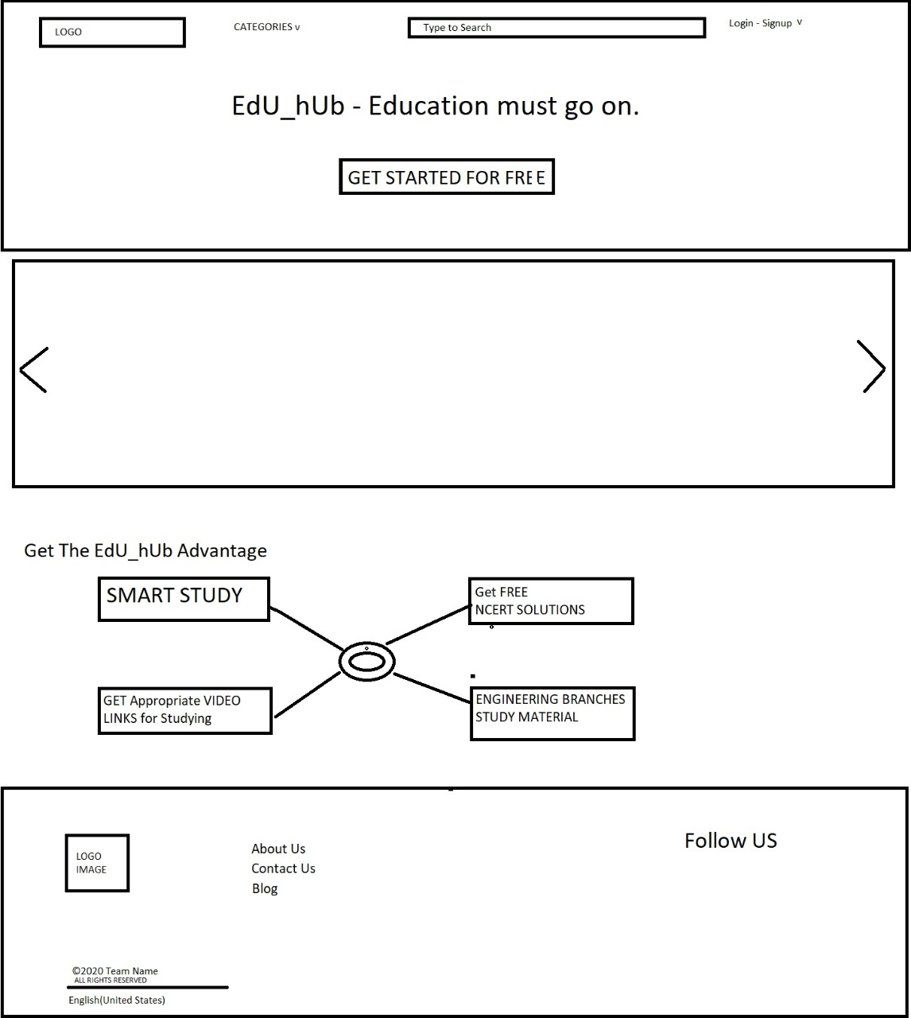

**4)Implementation and user interface**

**Implementation**

**Code snippets**

**index.php:**

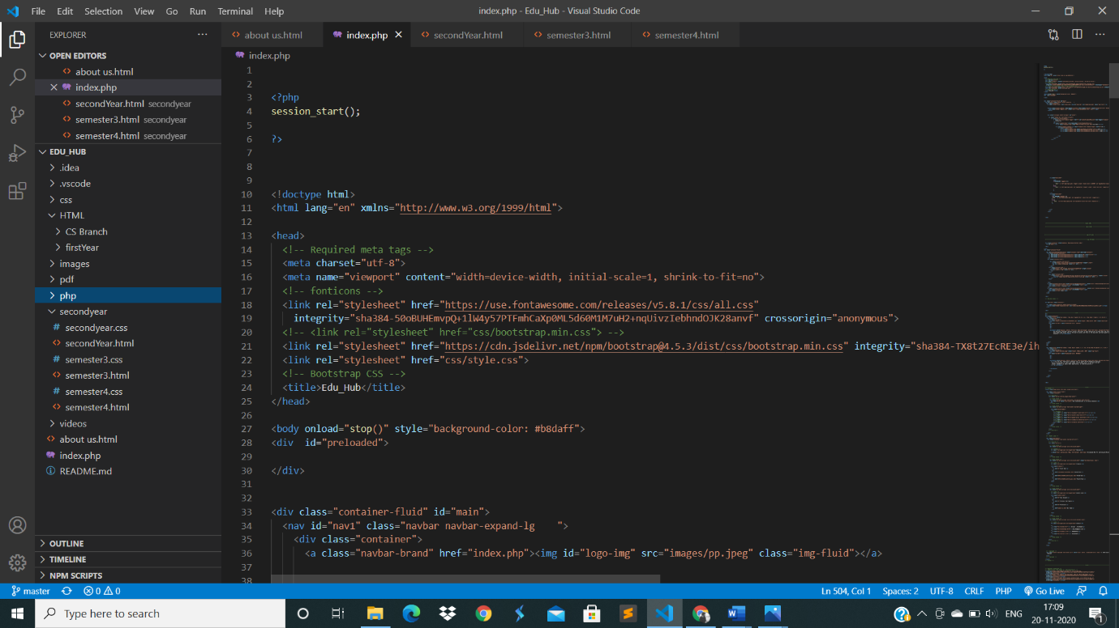

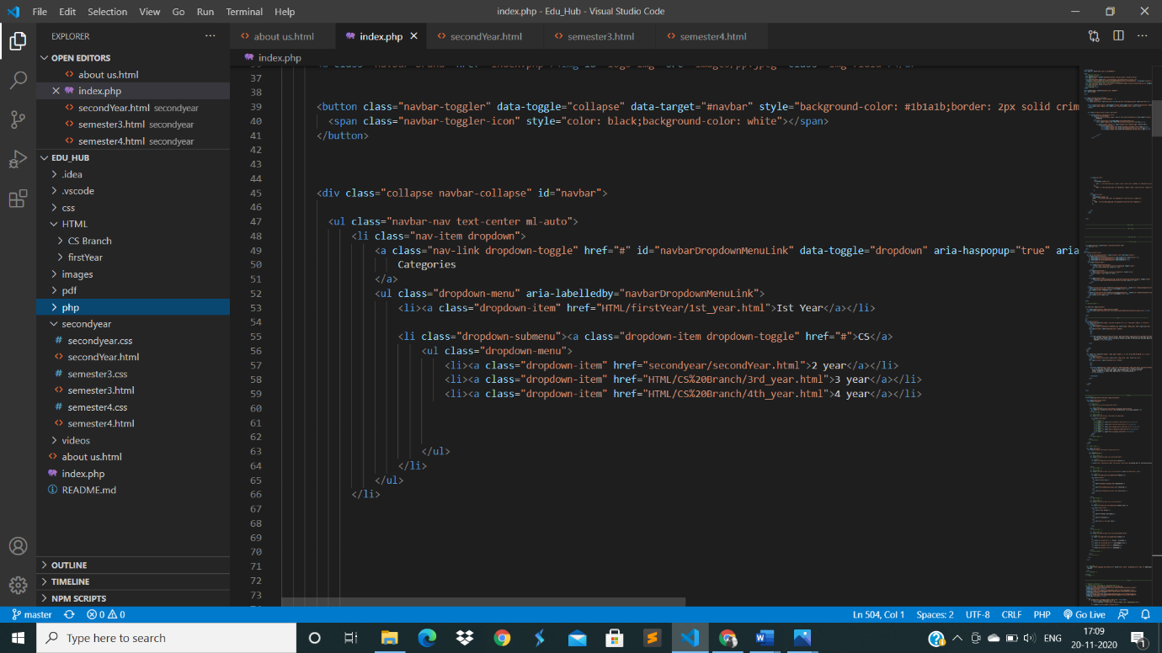

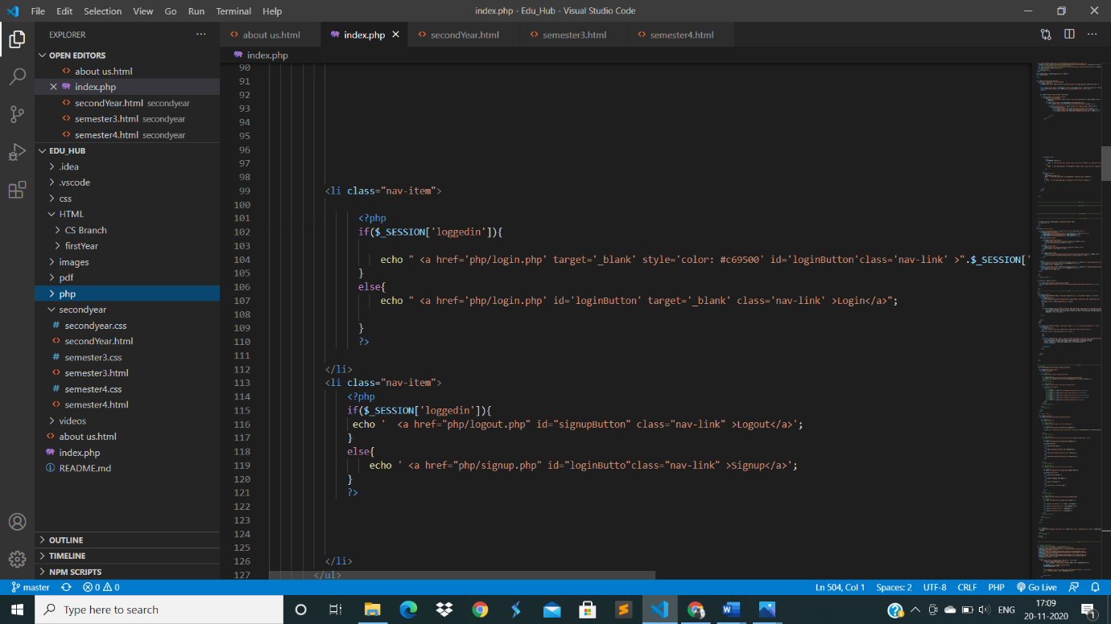

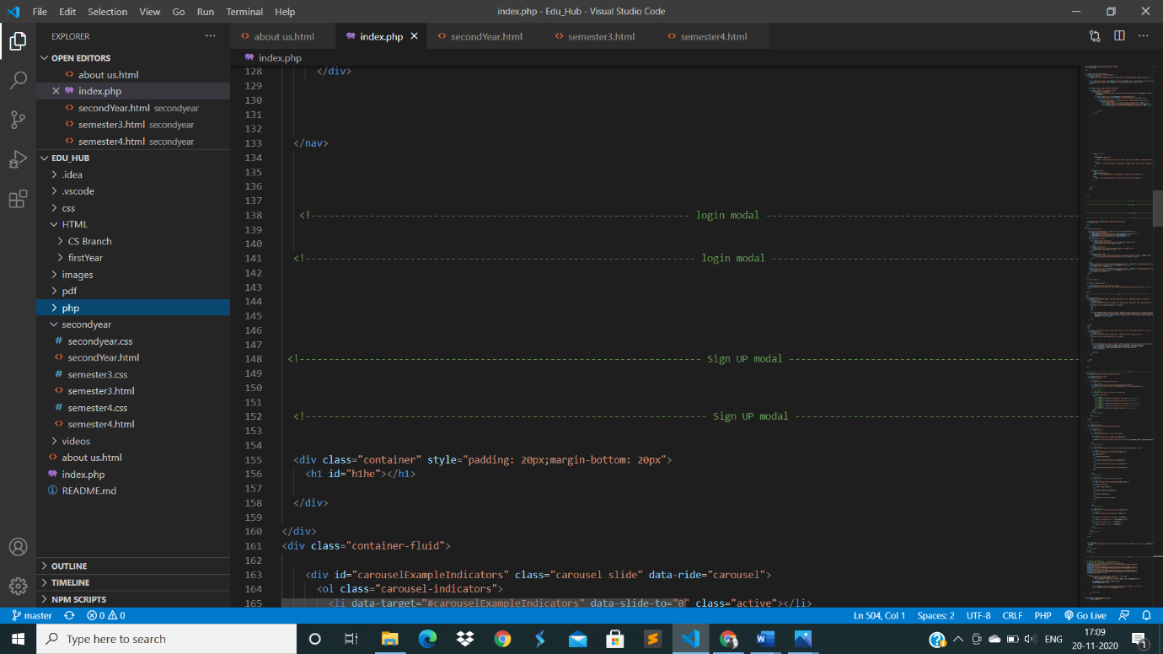

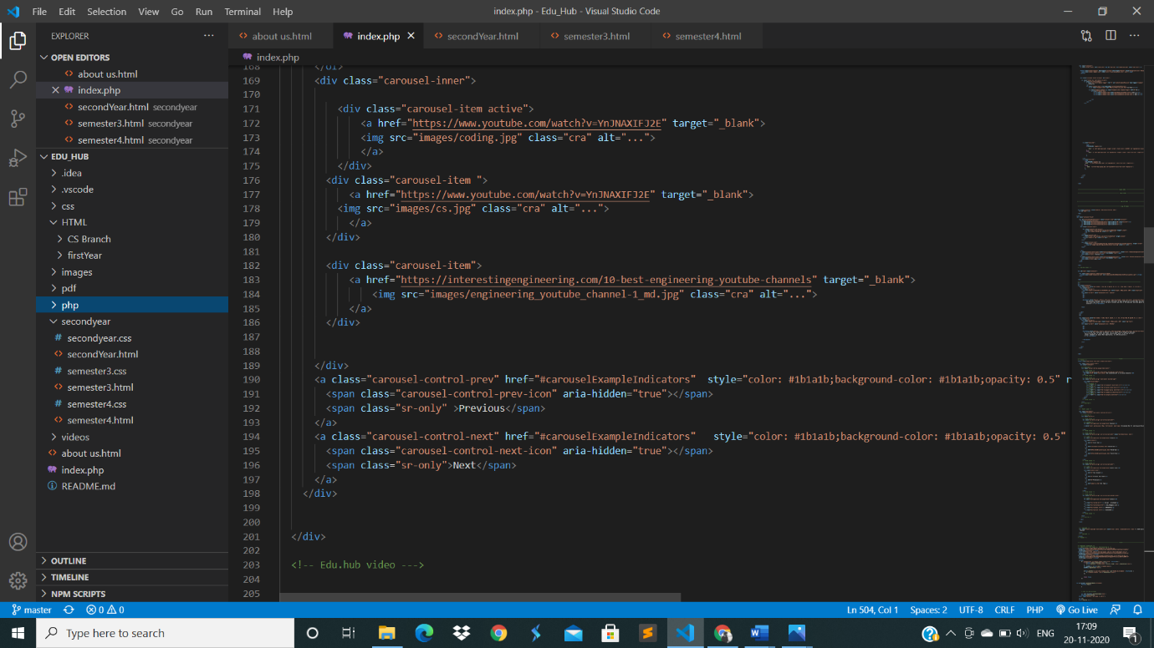

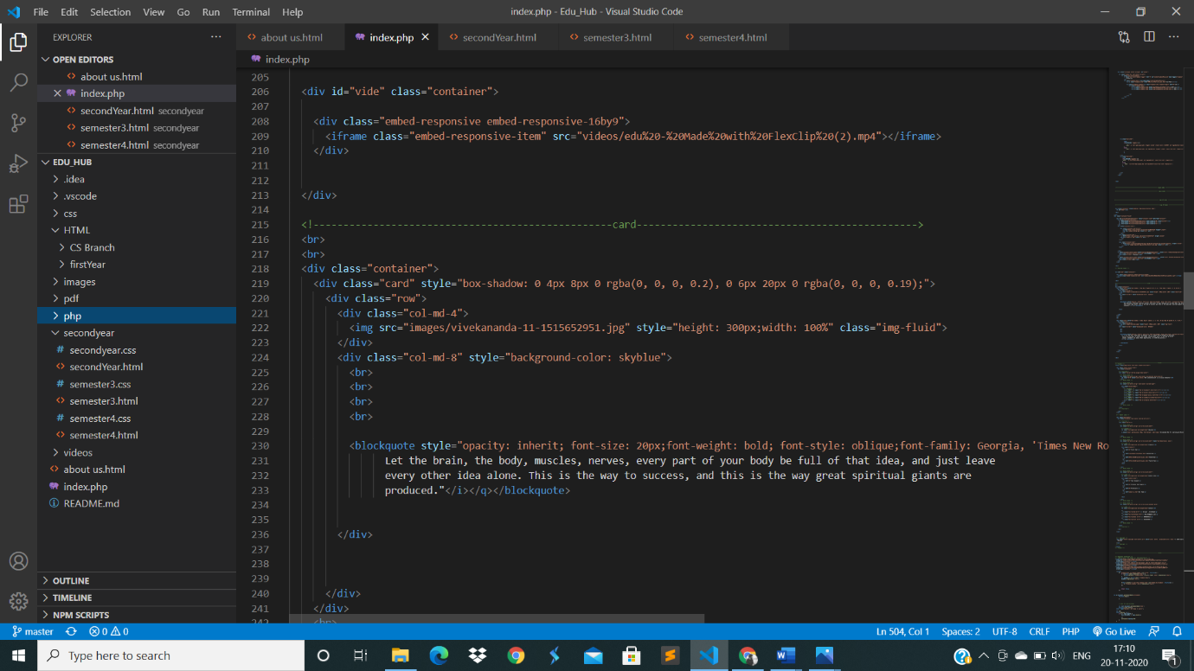

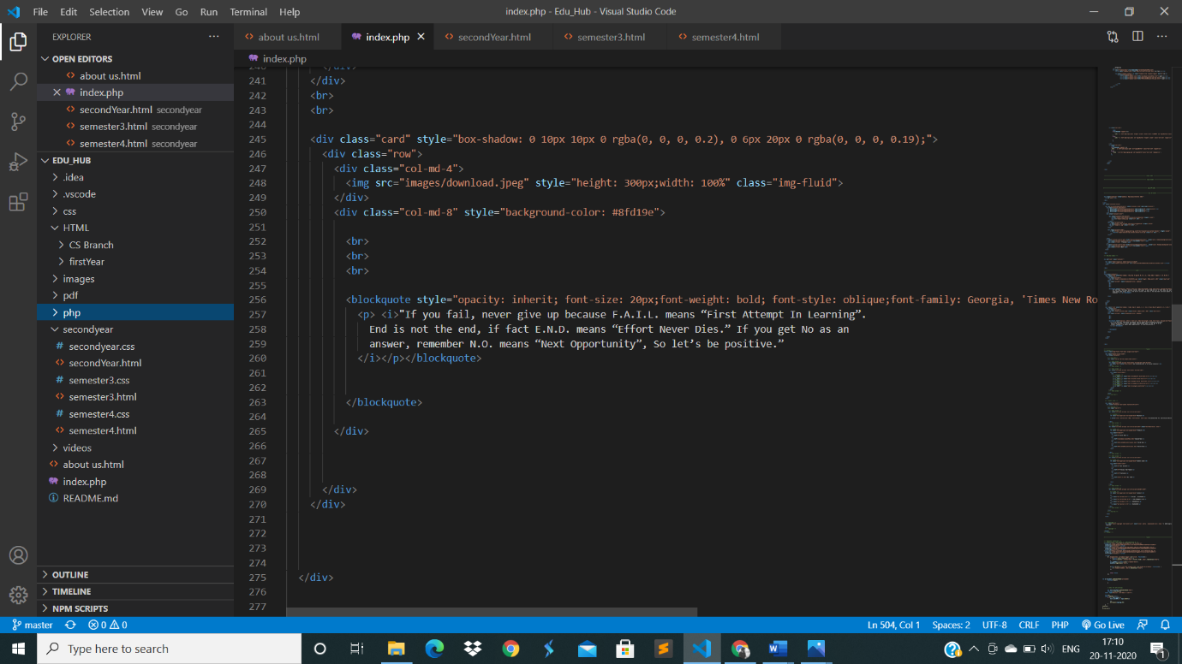

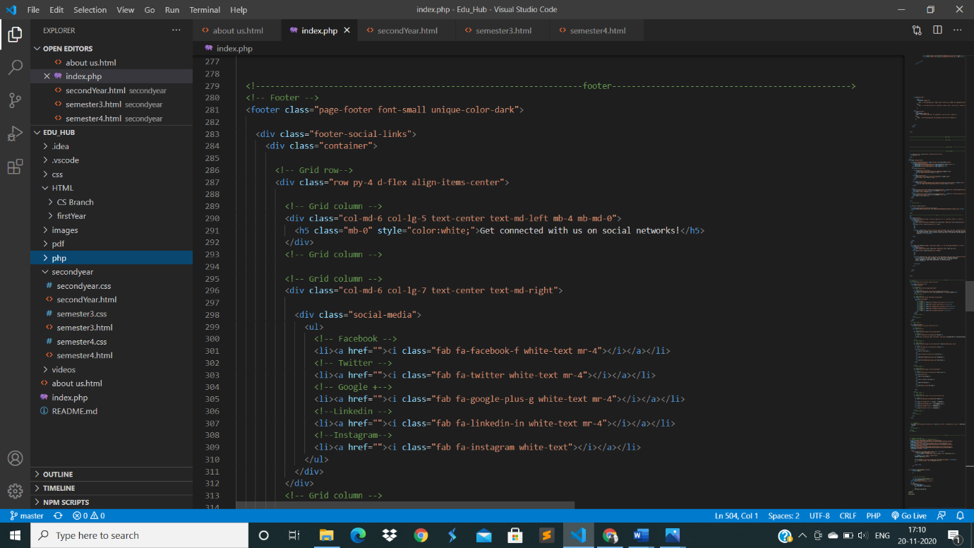

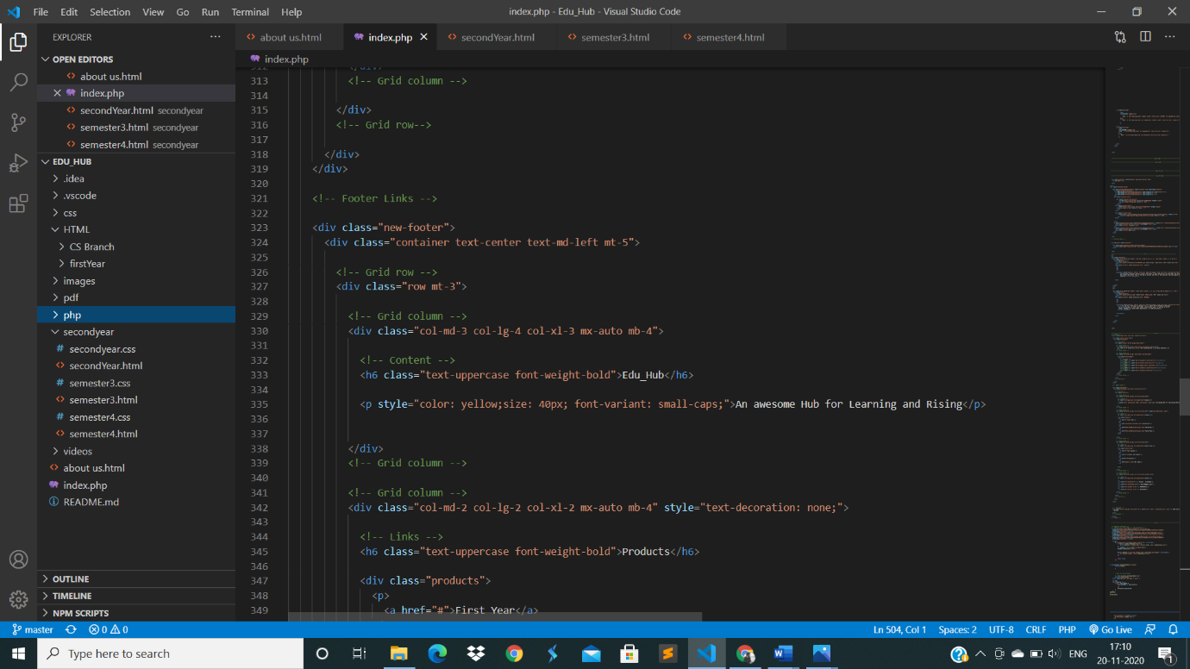

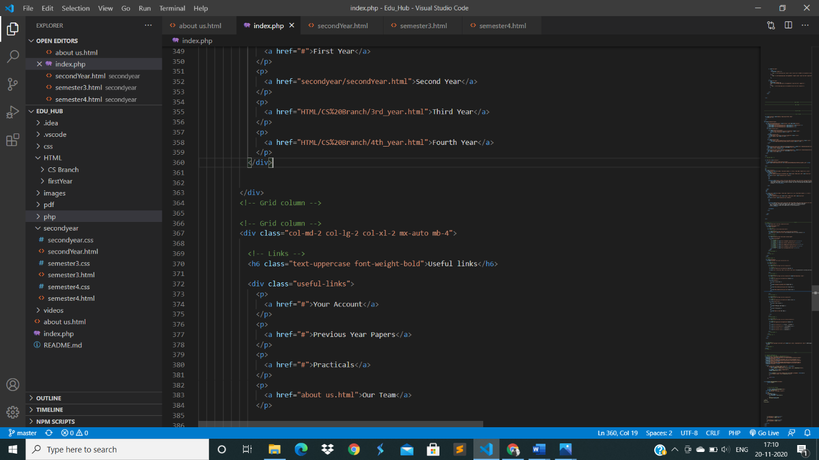

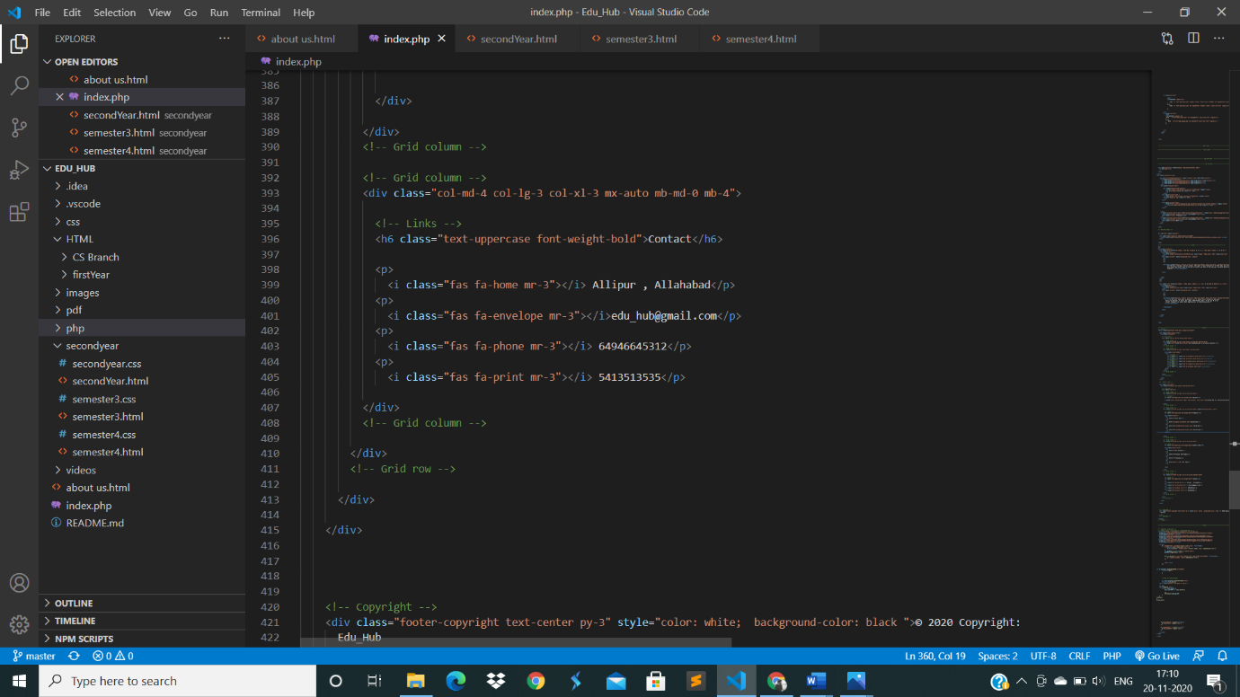

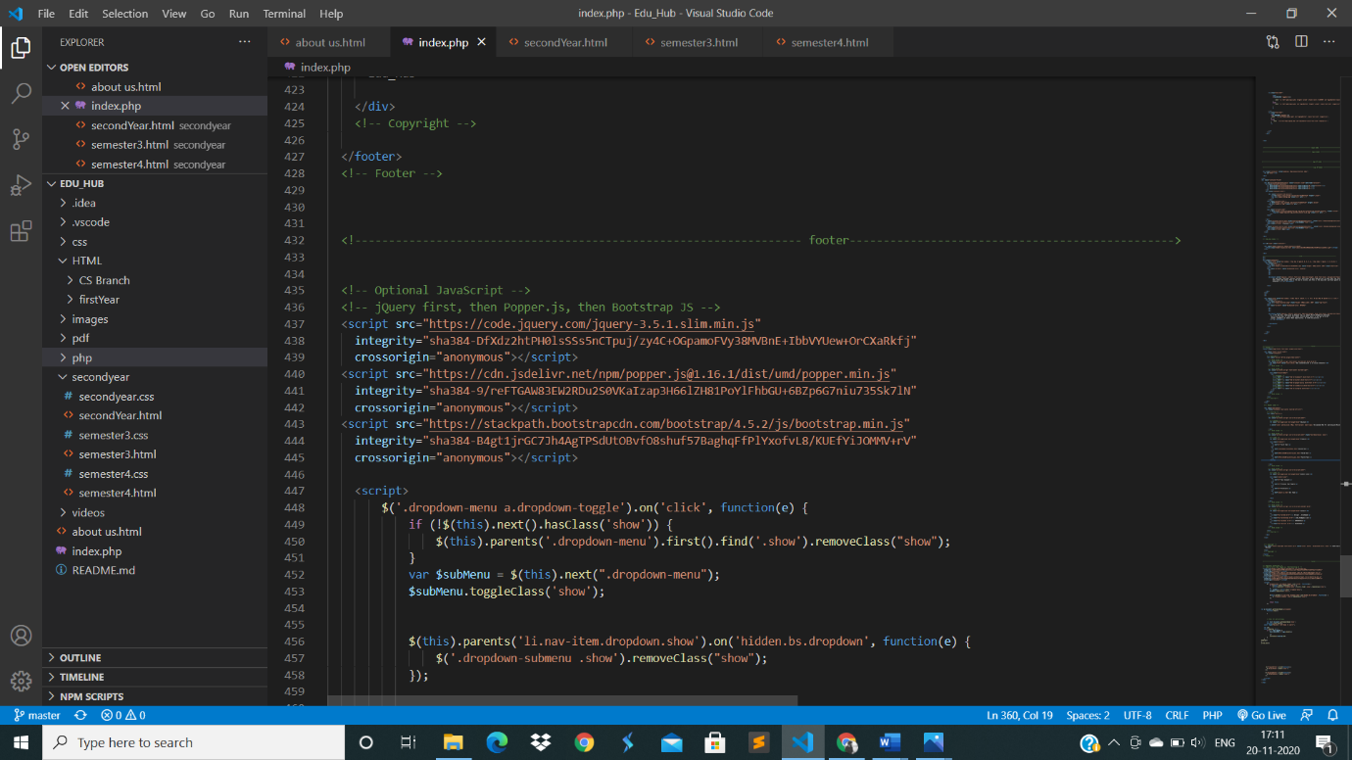

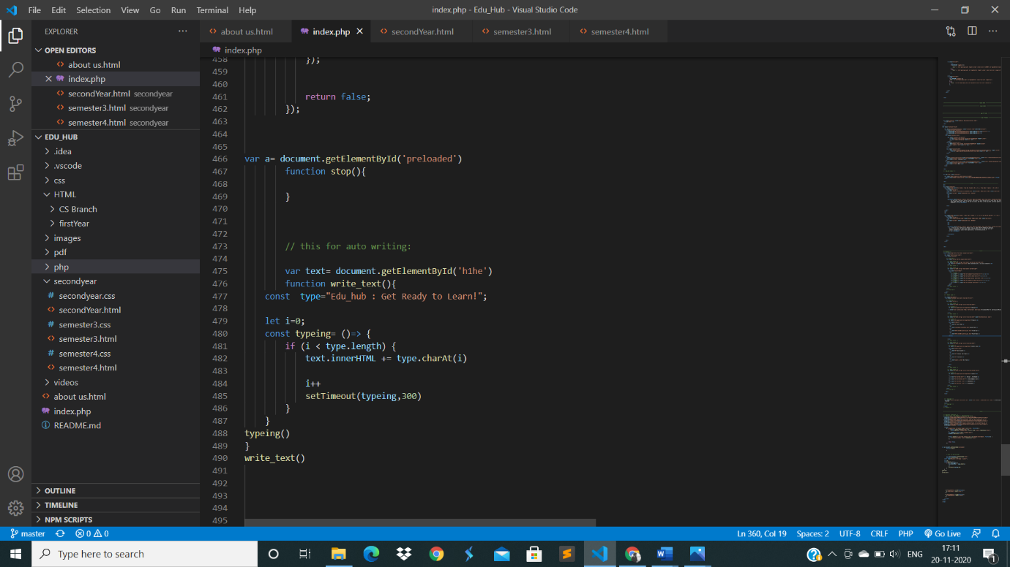

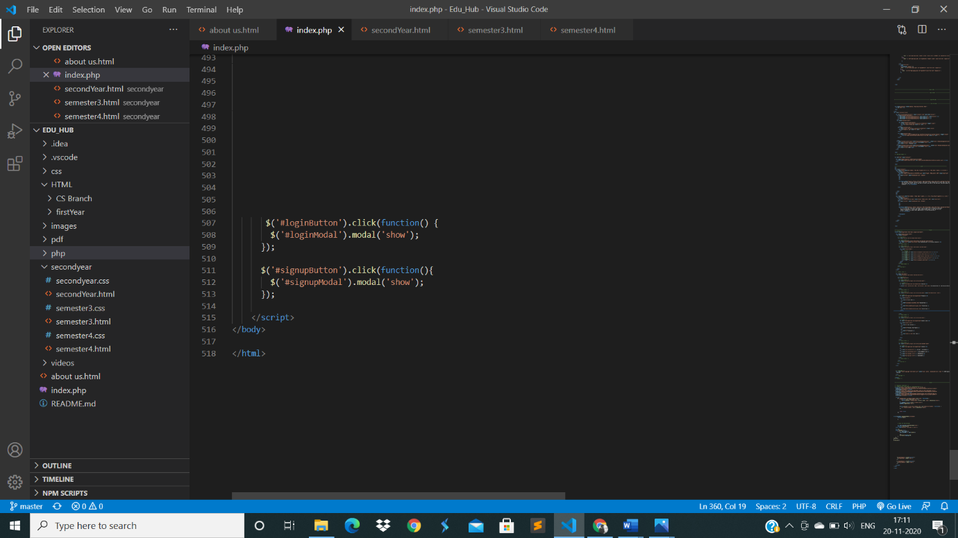

**User Interface**

**Screenshots**

**Homepage**

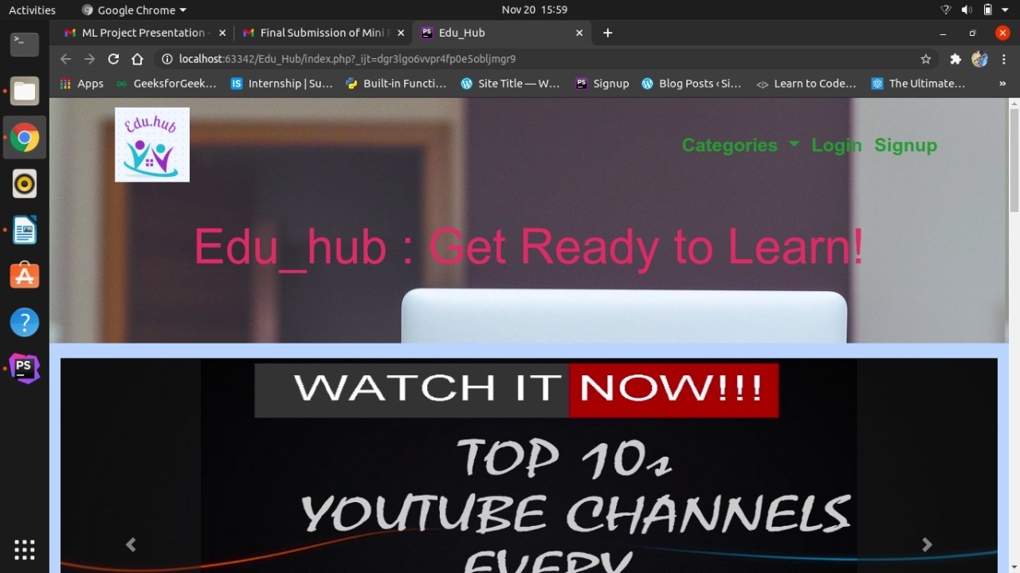

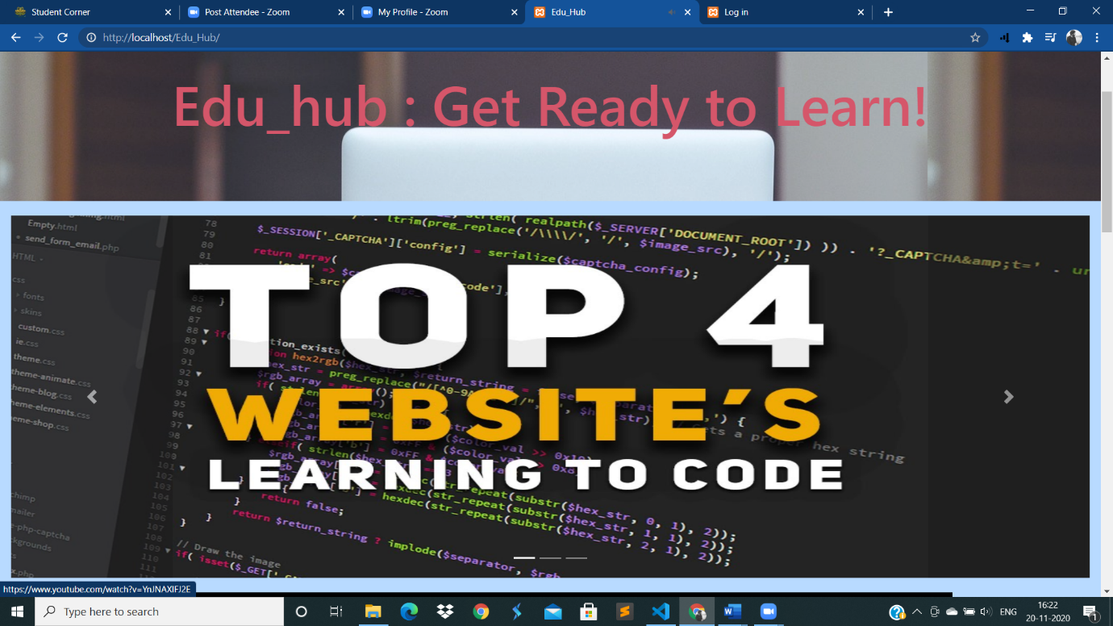

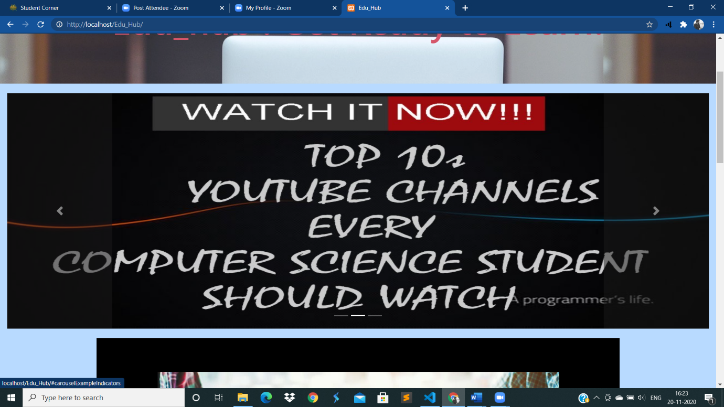

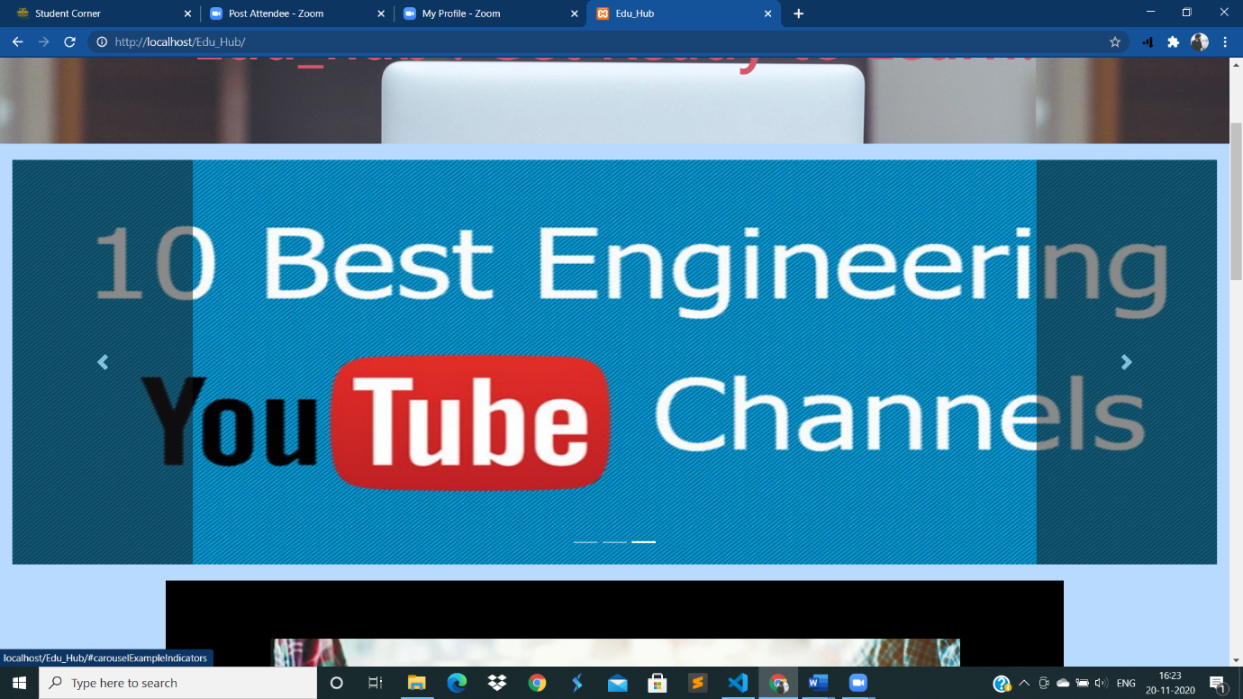

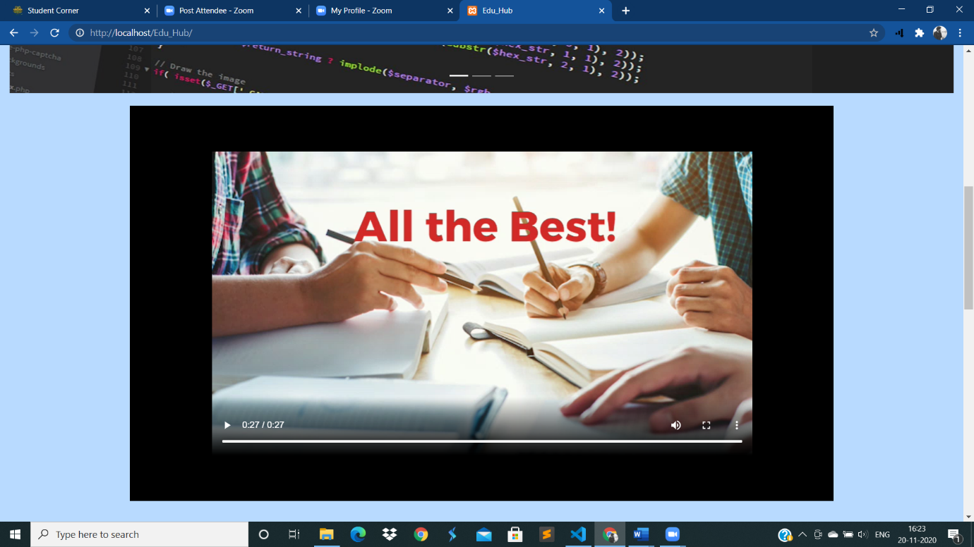

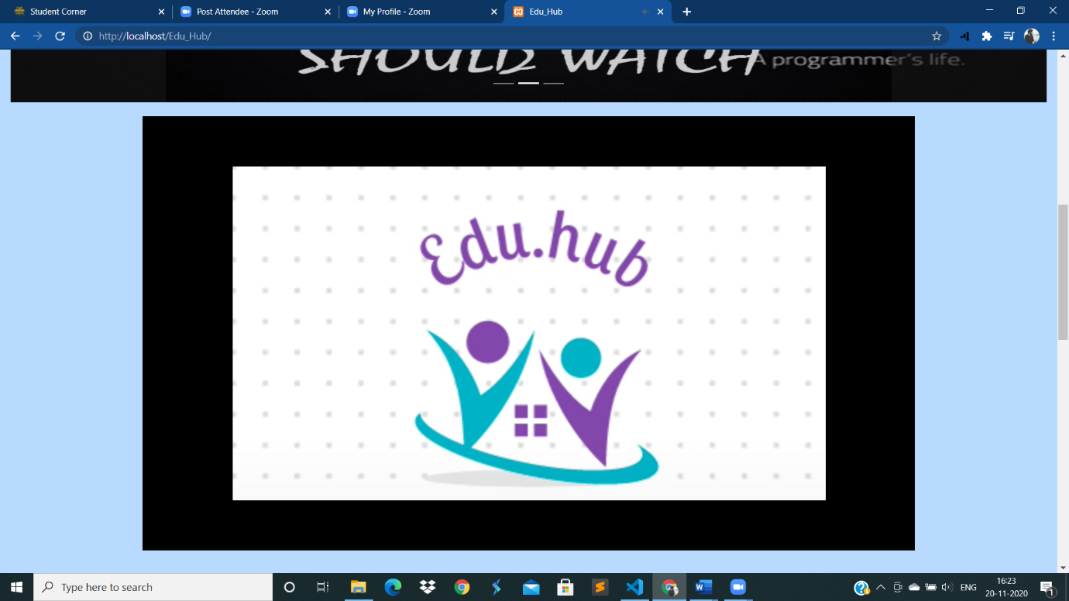

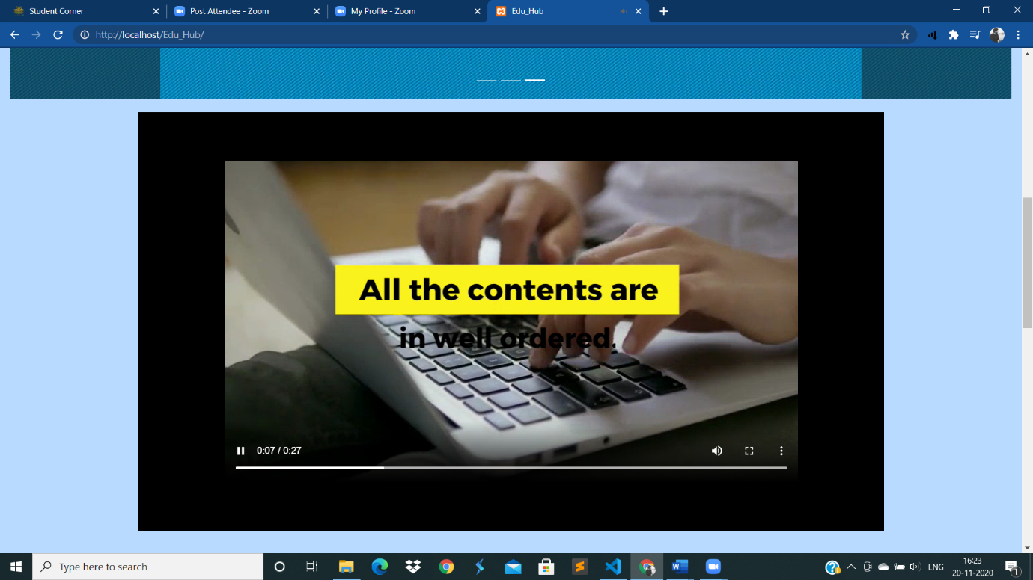

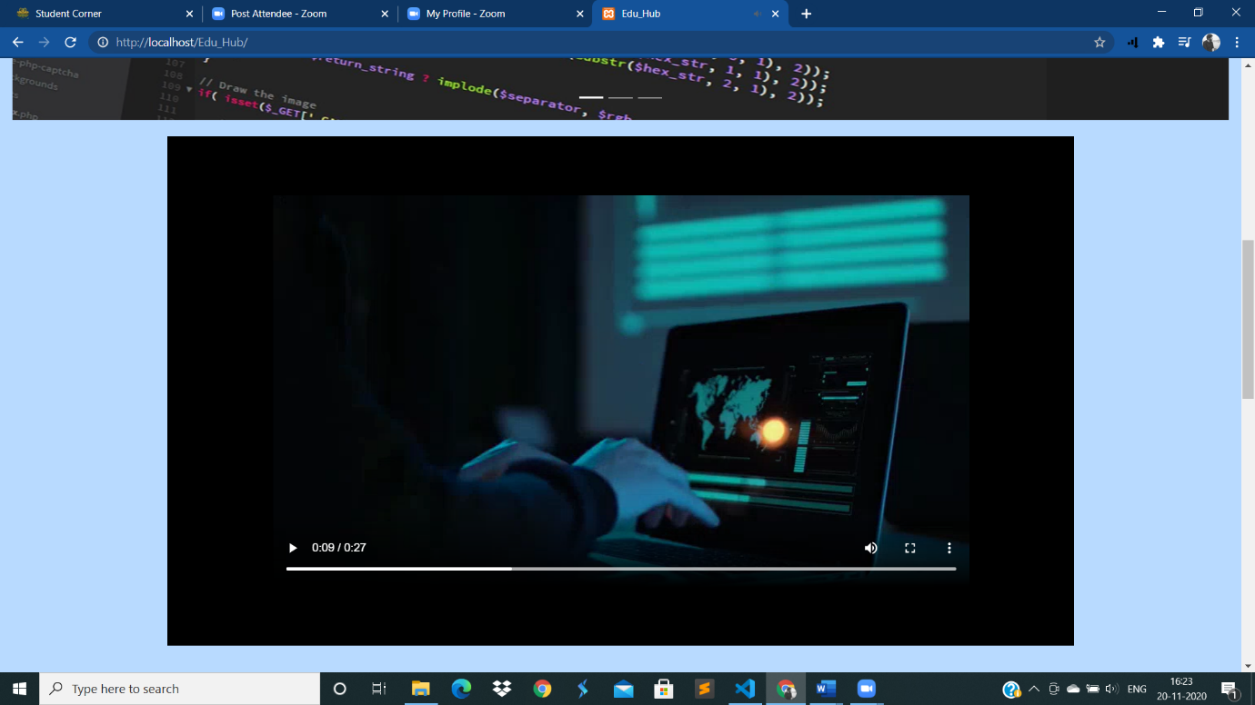

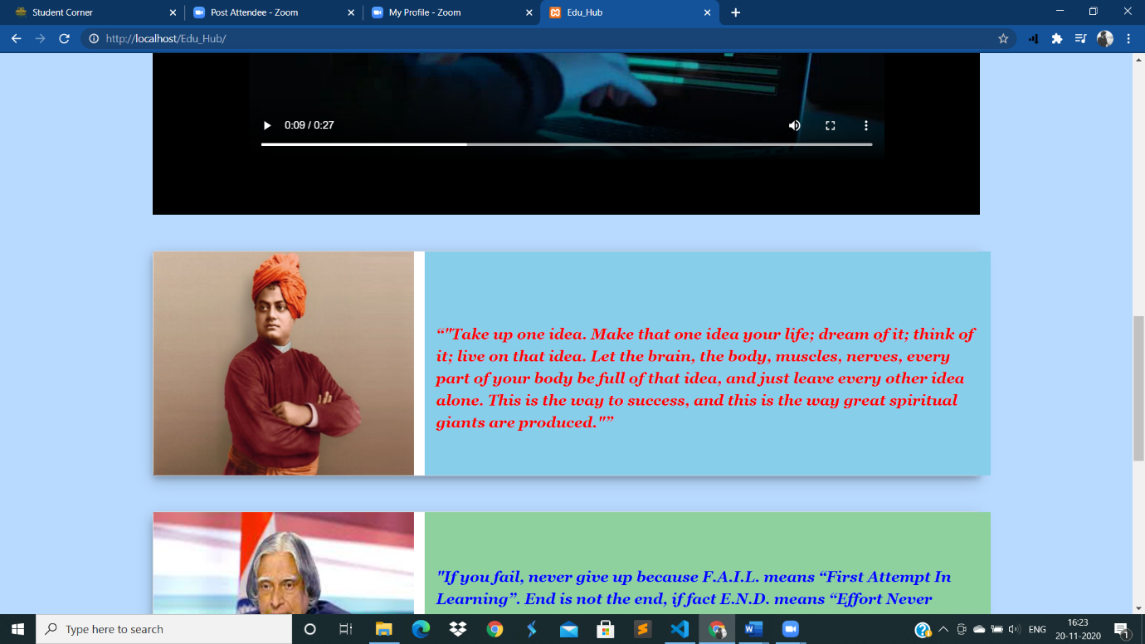

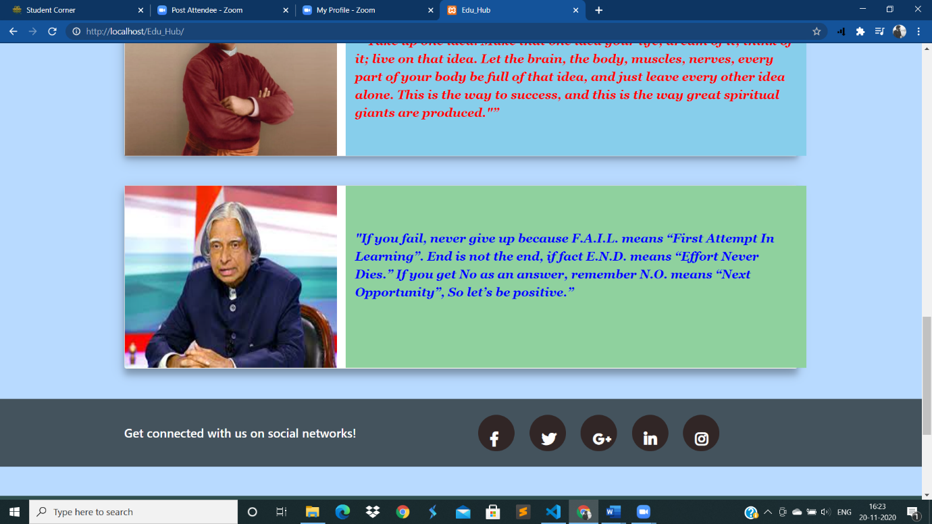

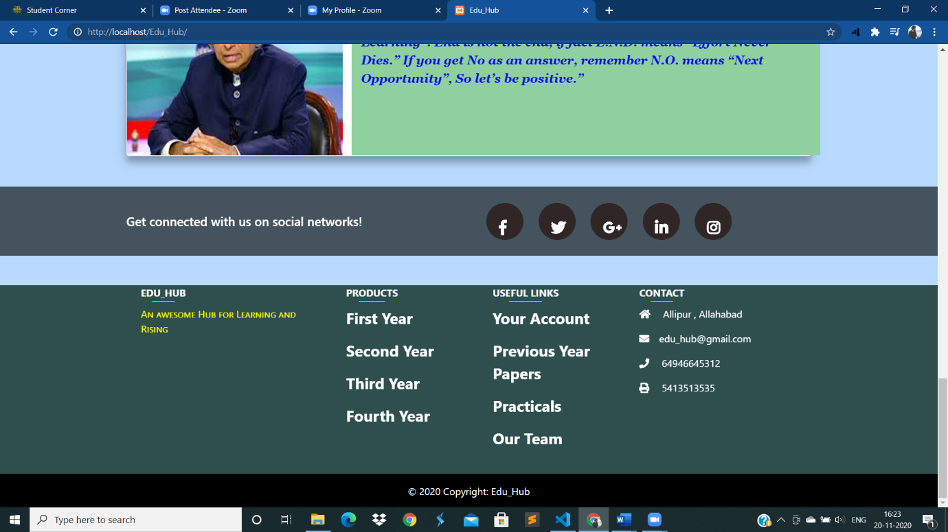

**Login and Signup pages:**

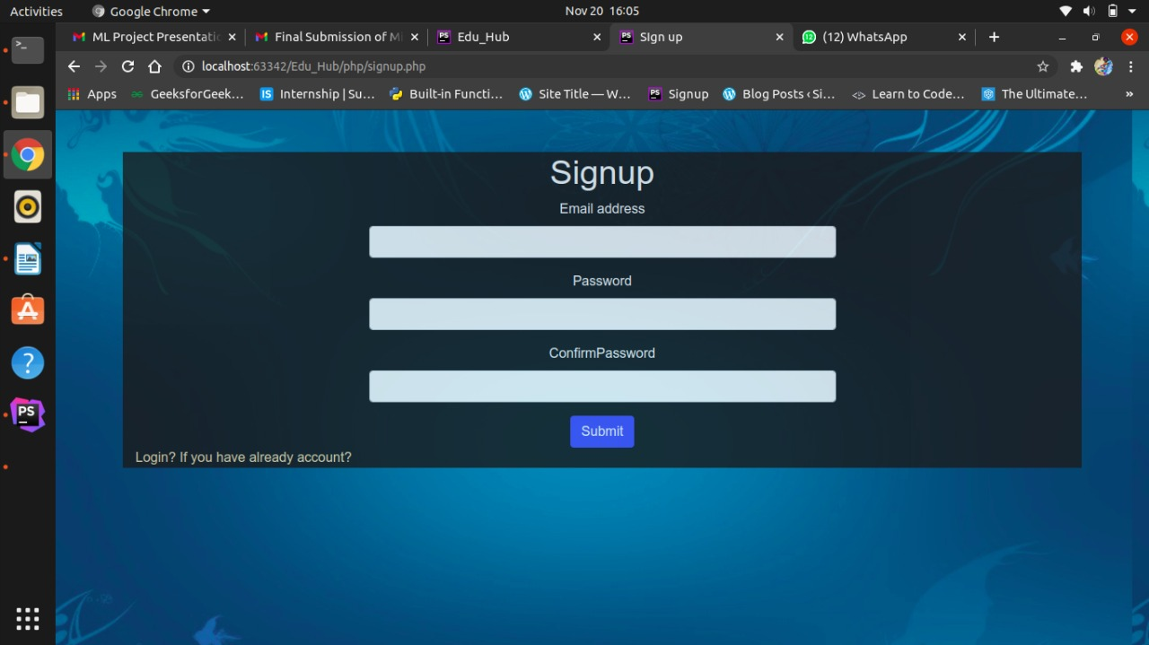

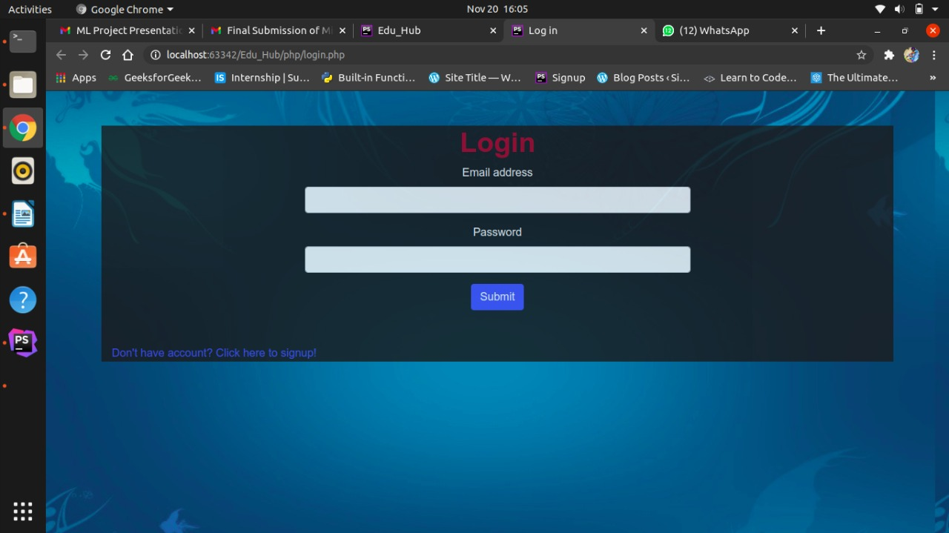

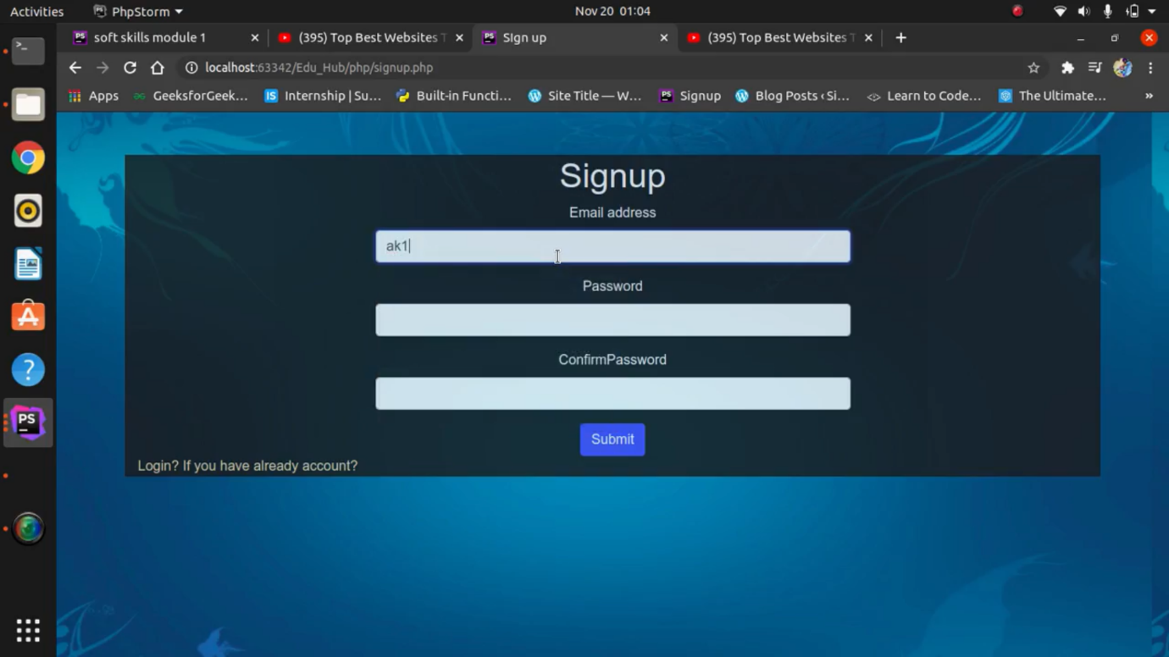

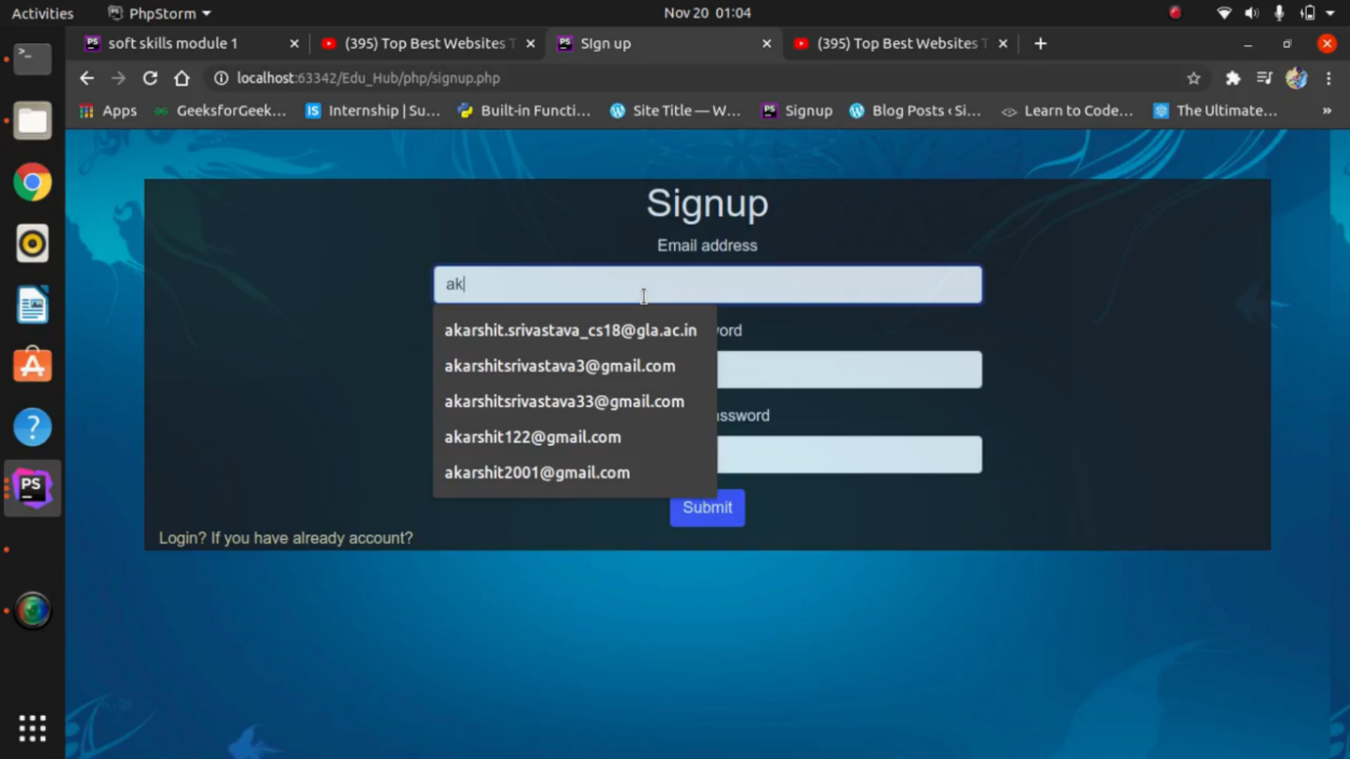

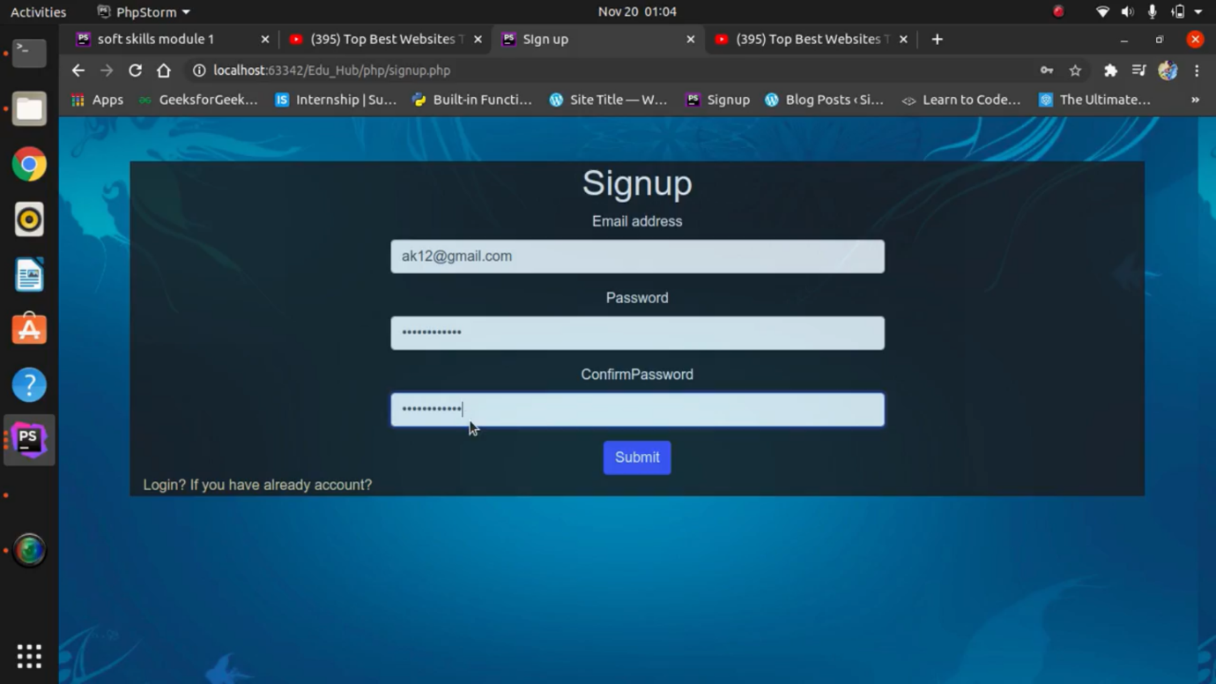

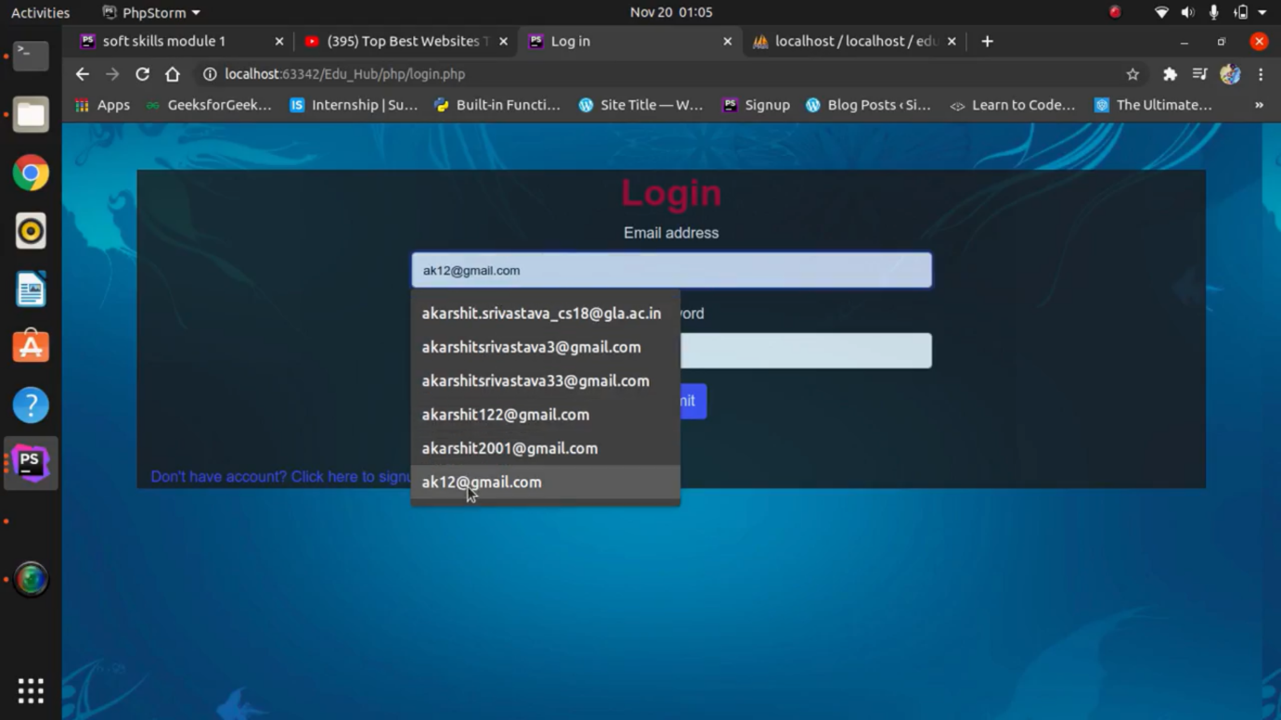

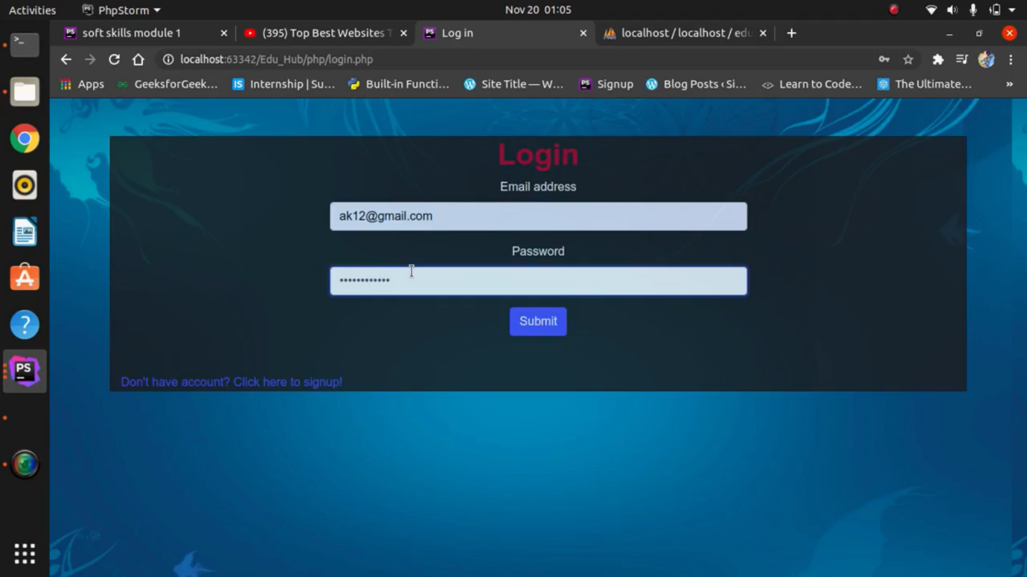

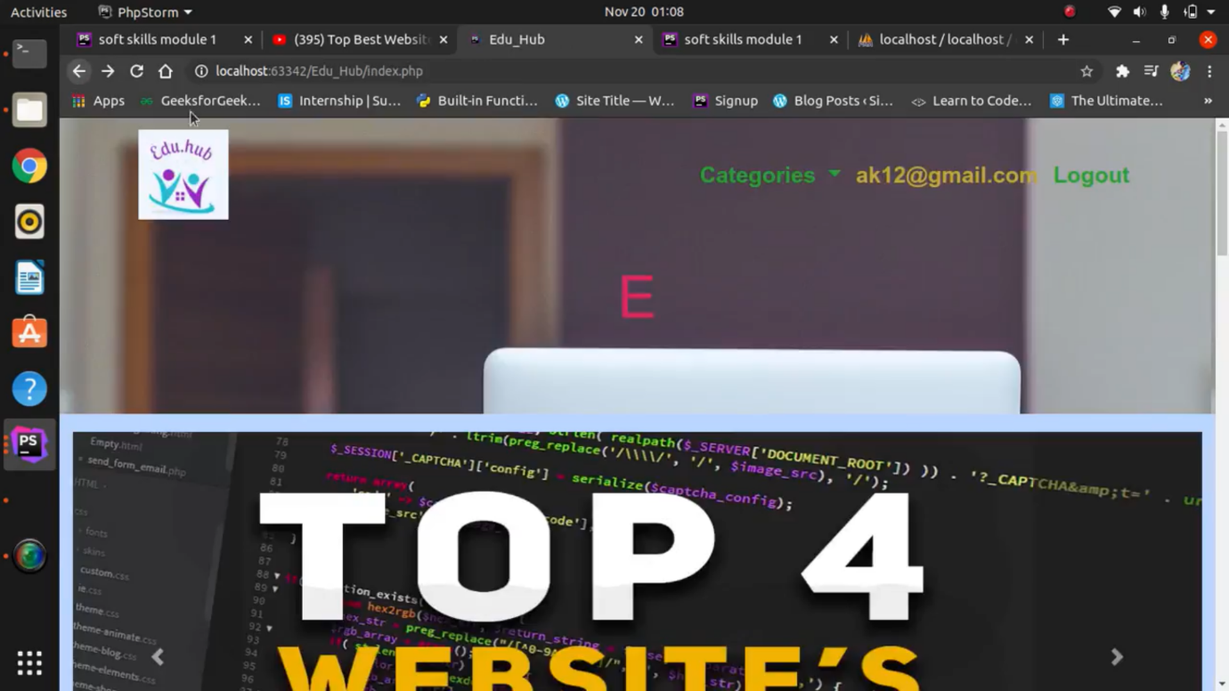

**Database:**

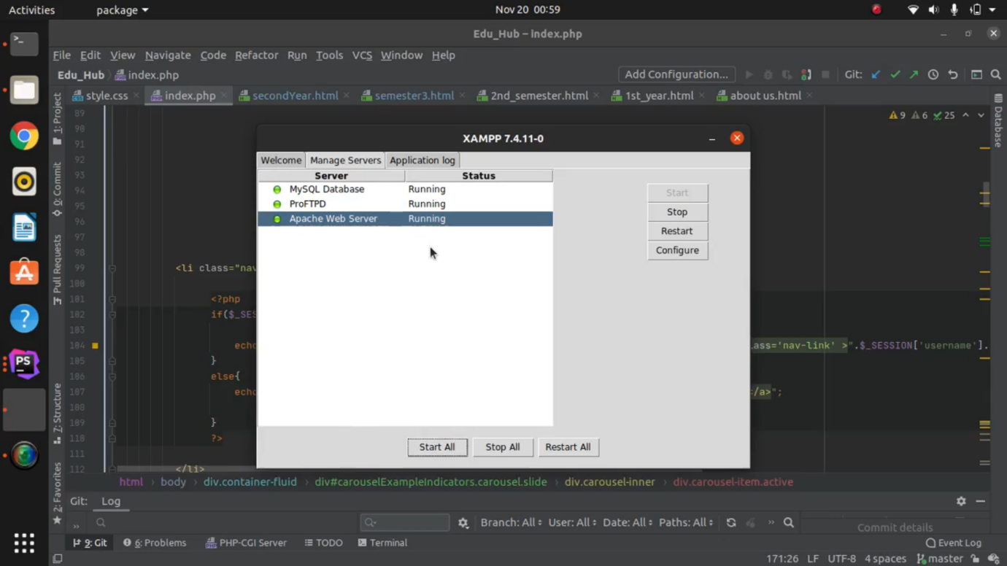

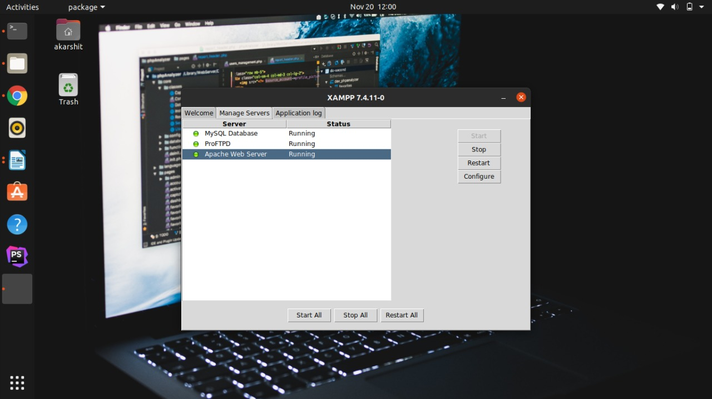

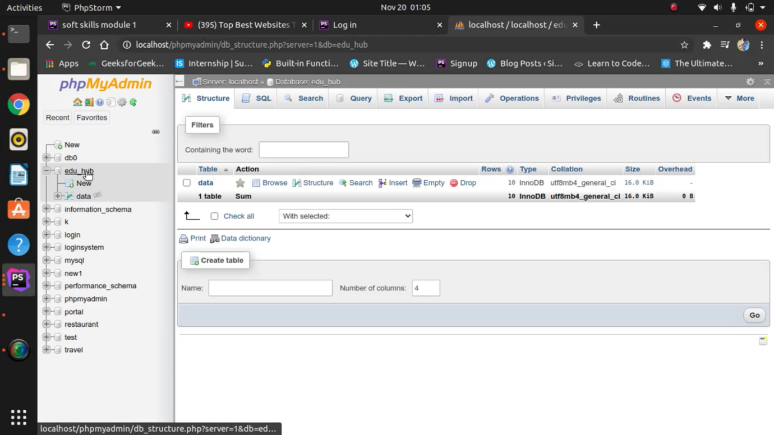

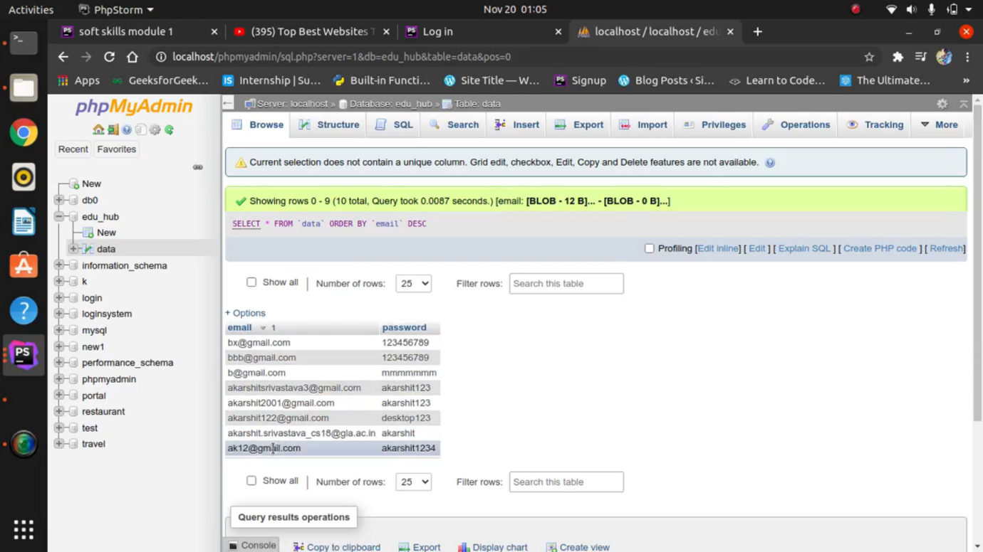

**Some snippets of uploaded pdf’s:**

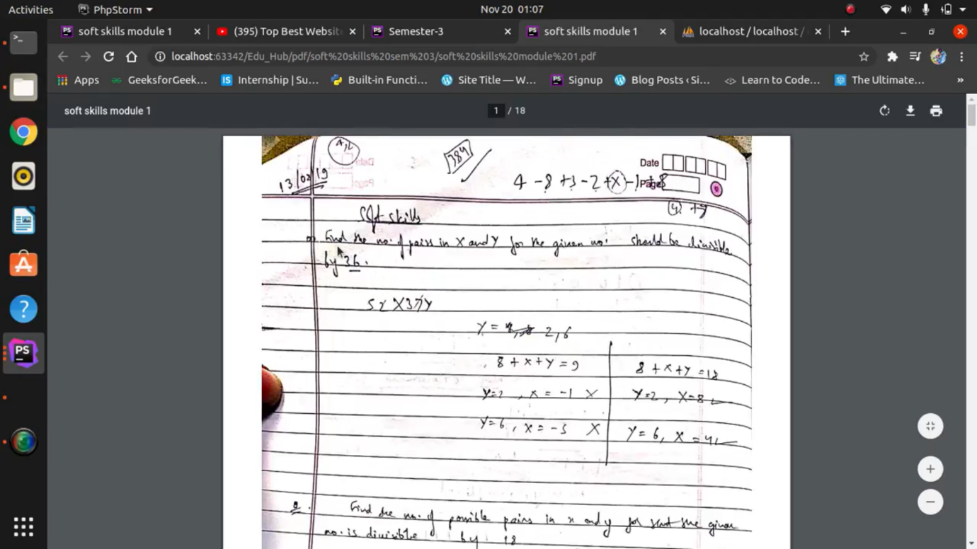

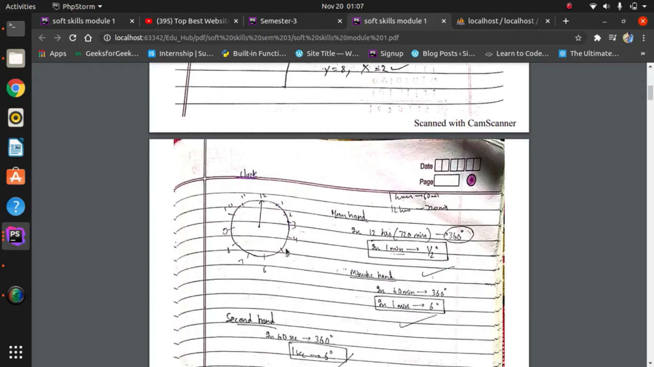

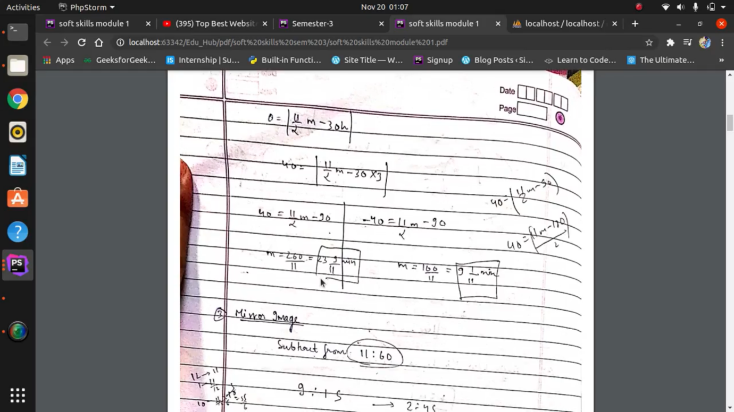

**Rest of the pages:**

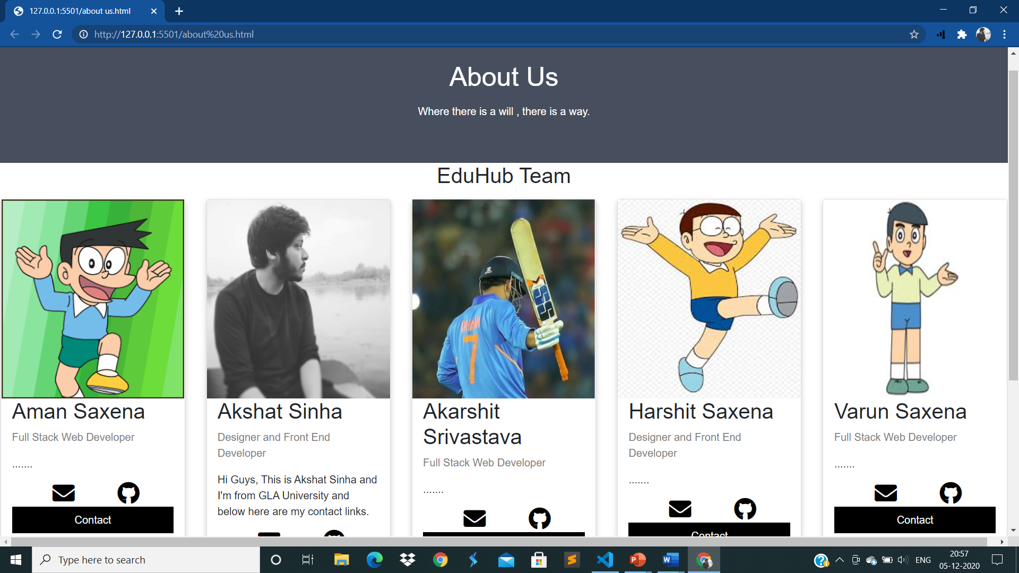



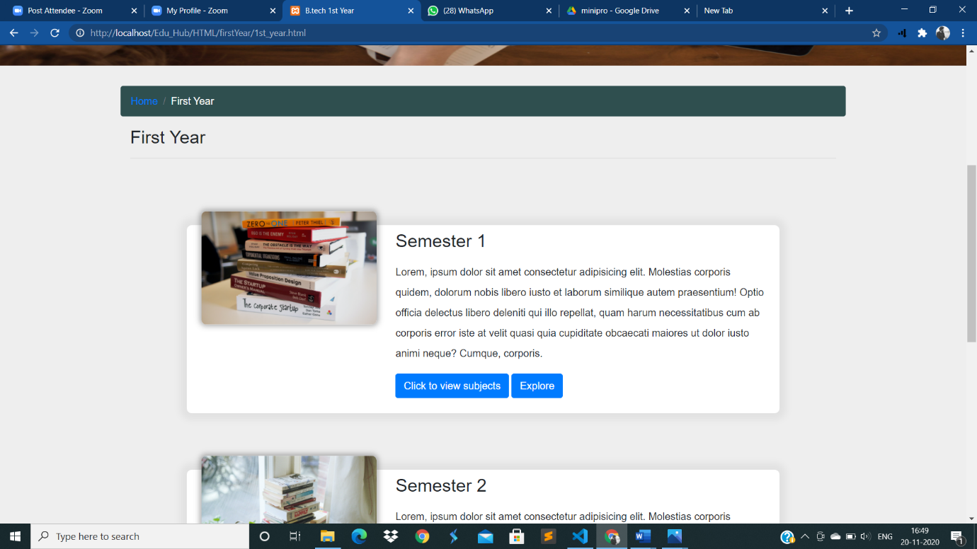

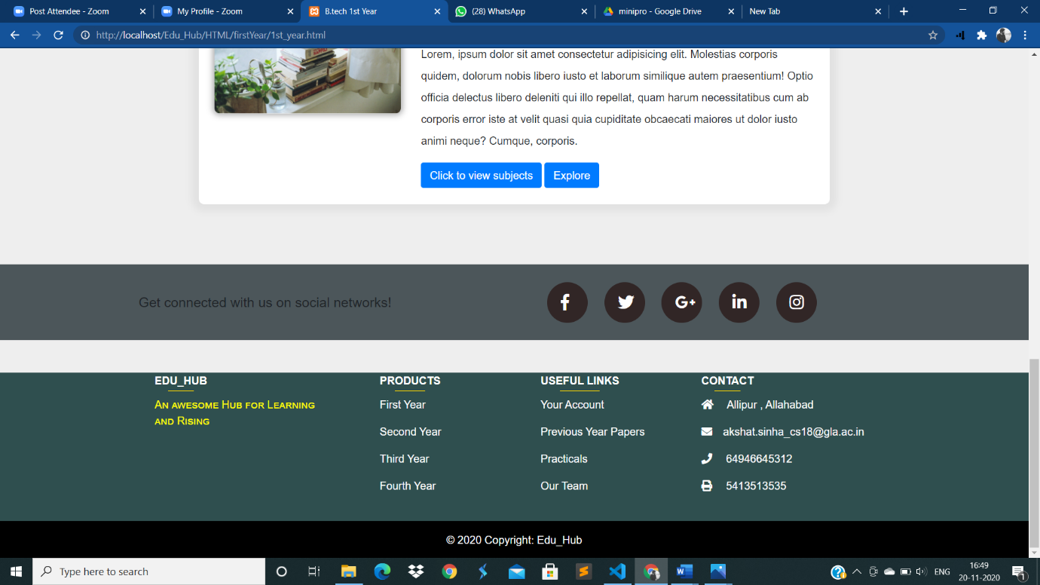

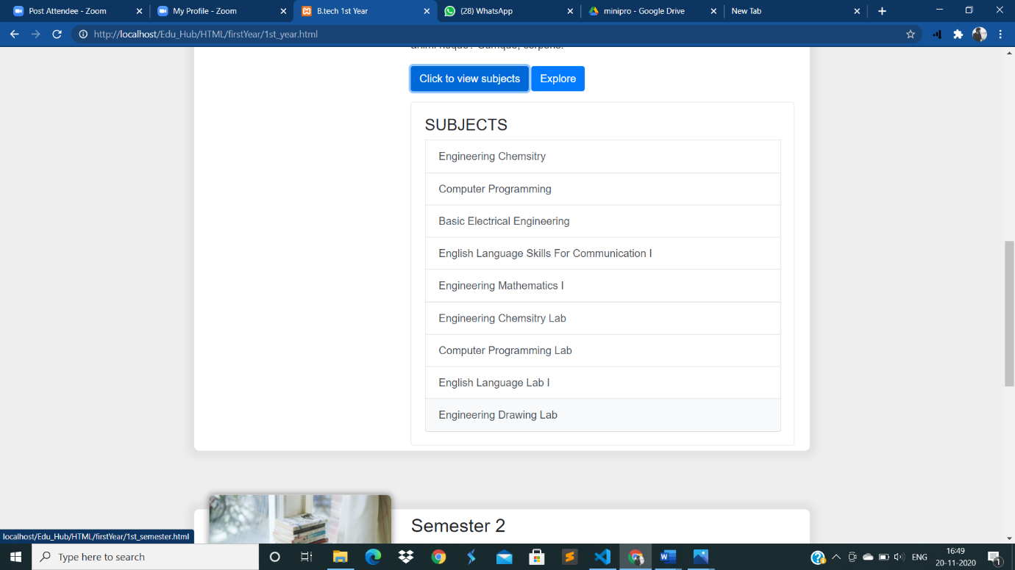

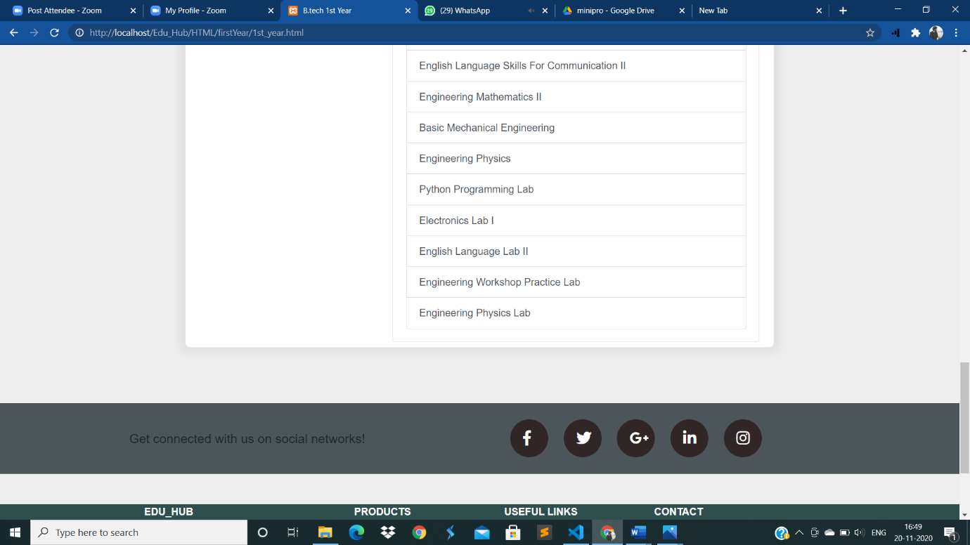

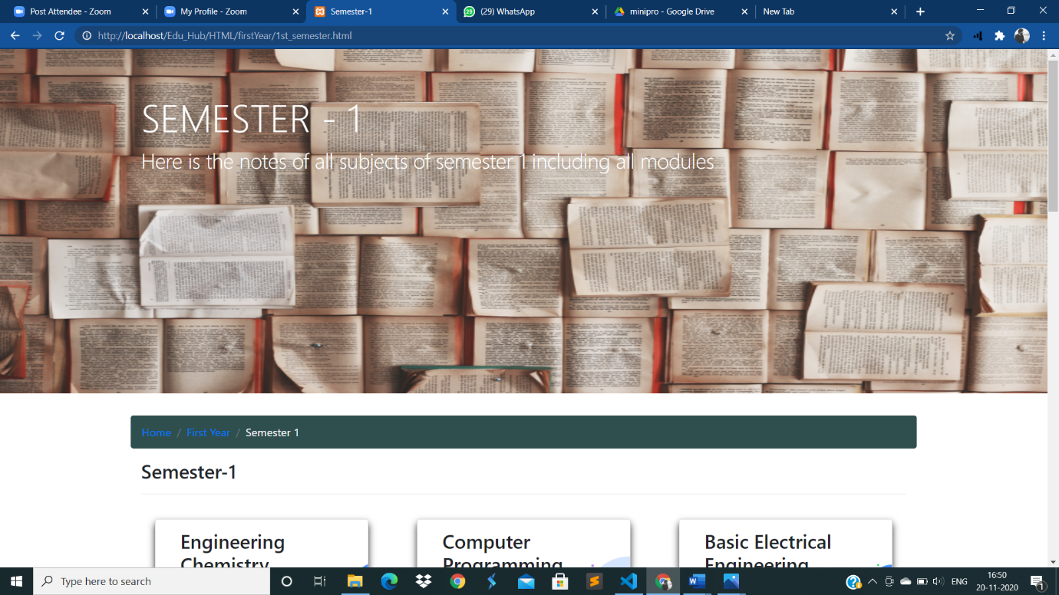

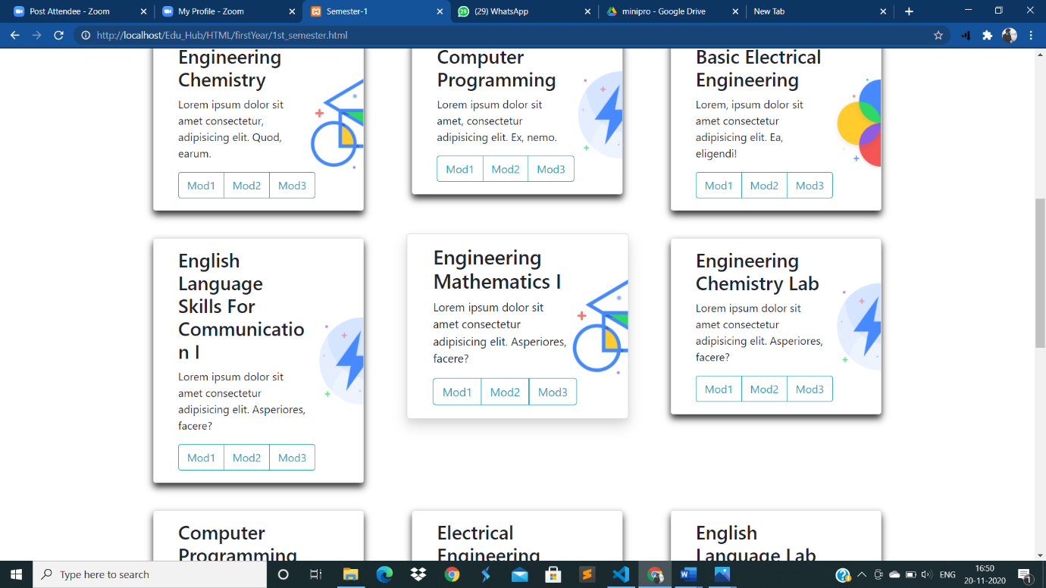

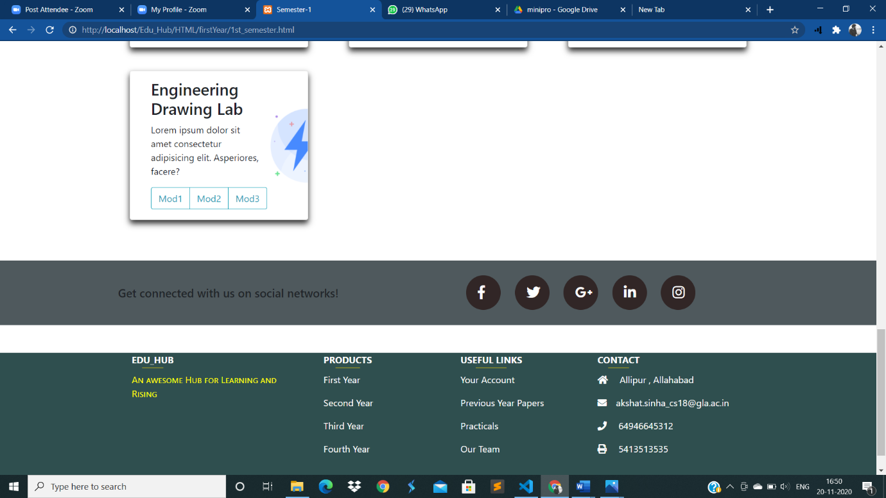

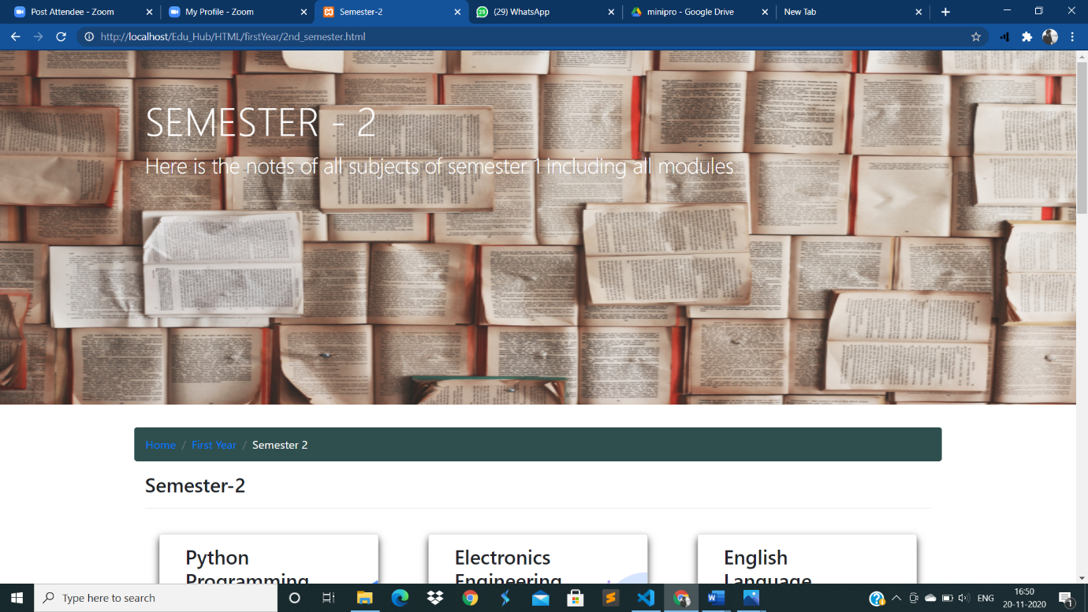

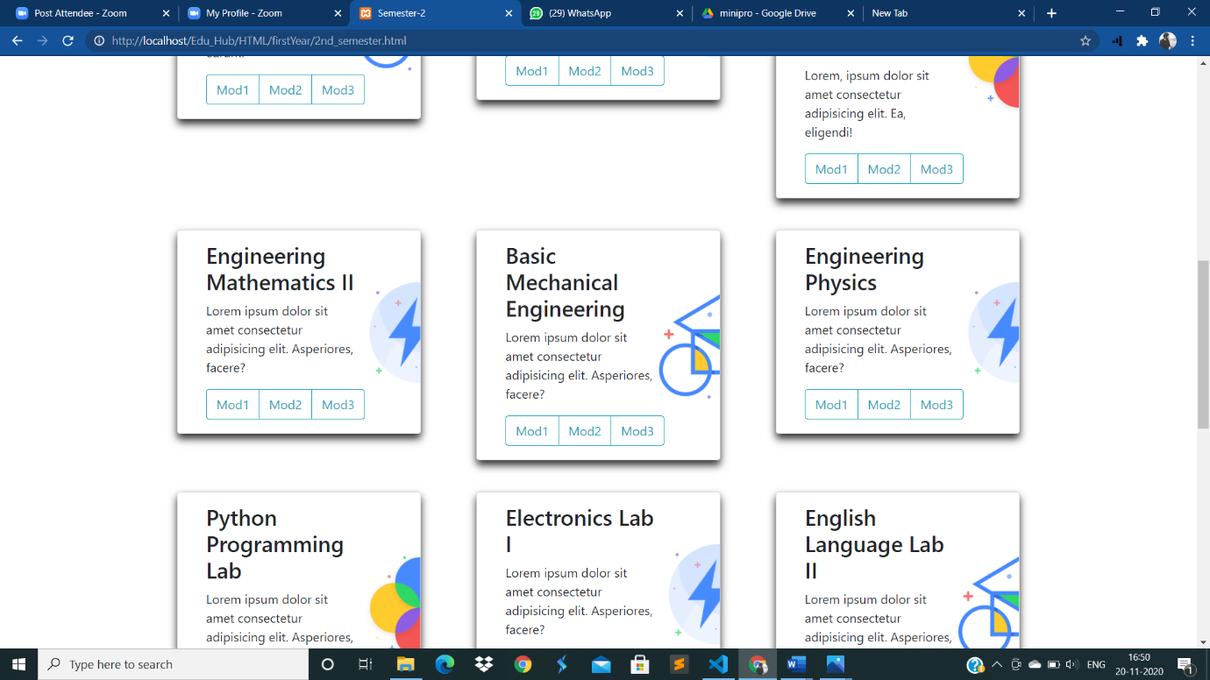

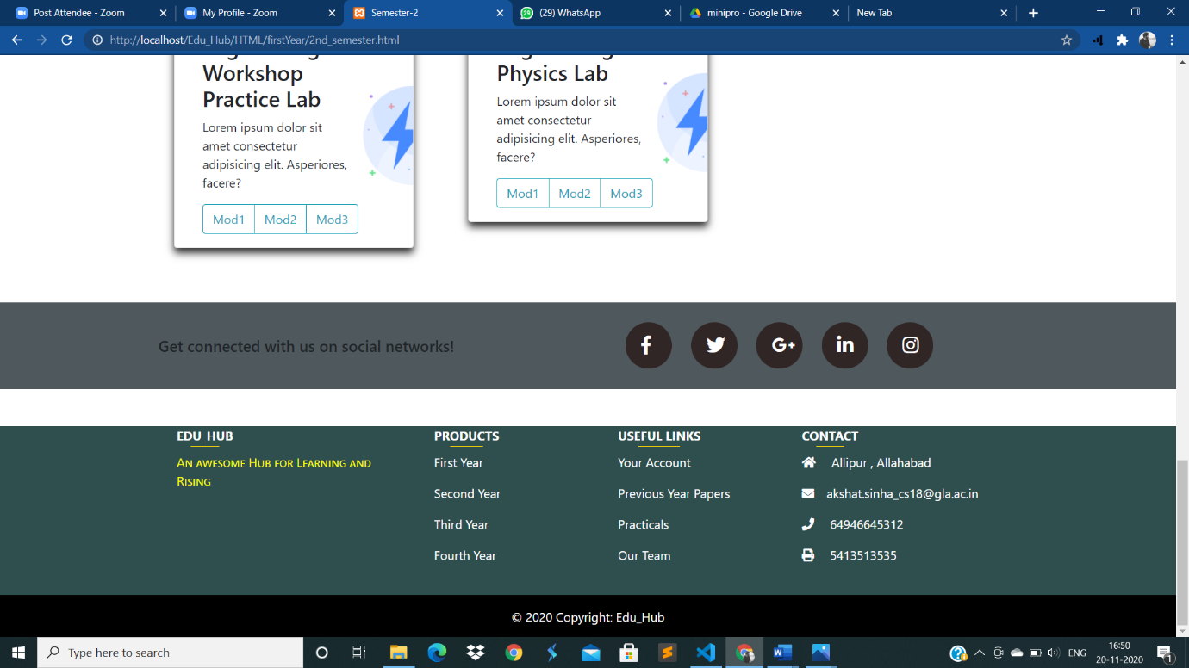



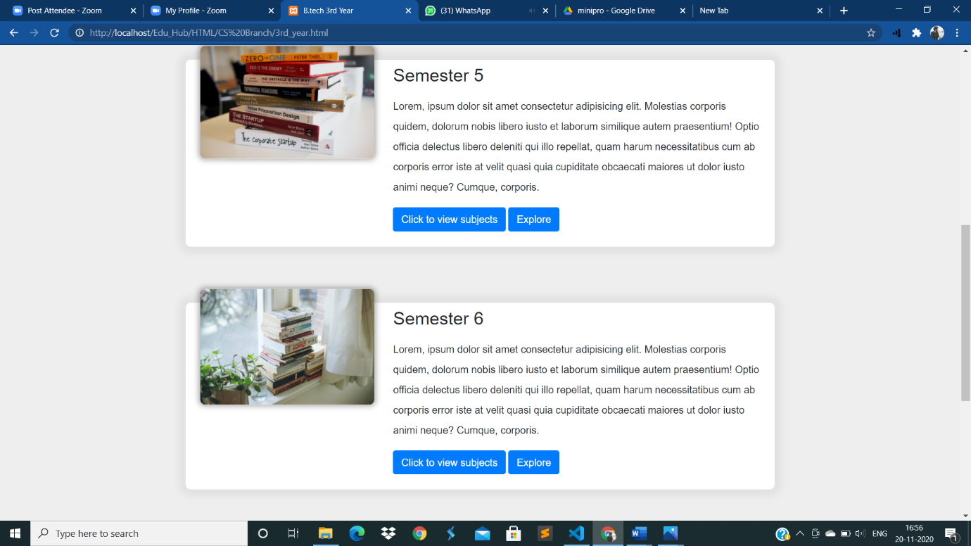

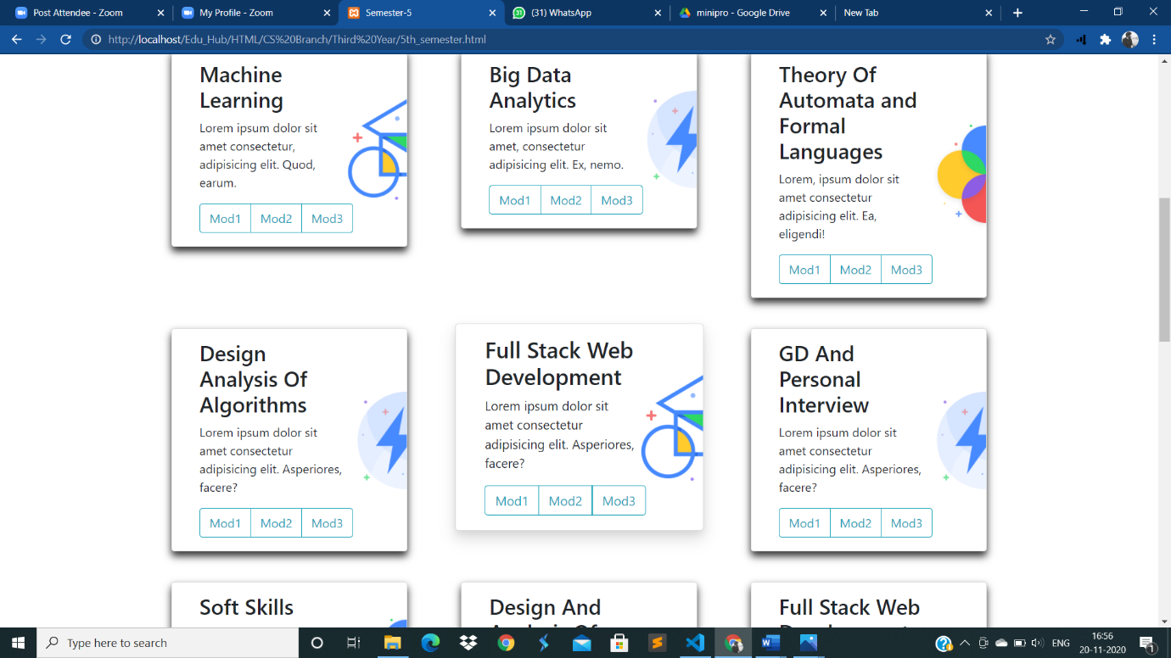

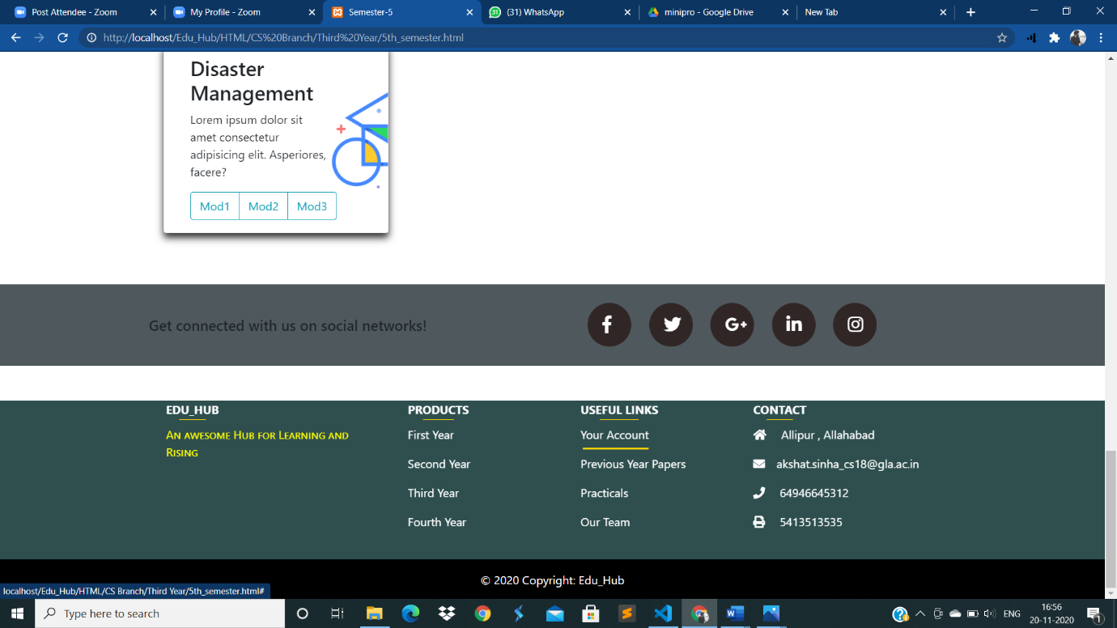

**Responsive Design:**

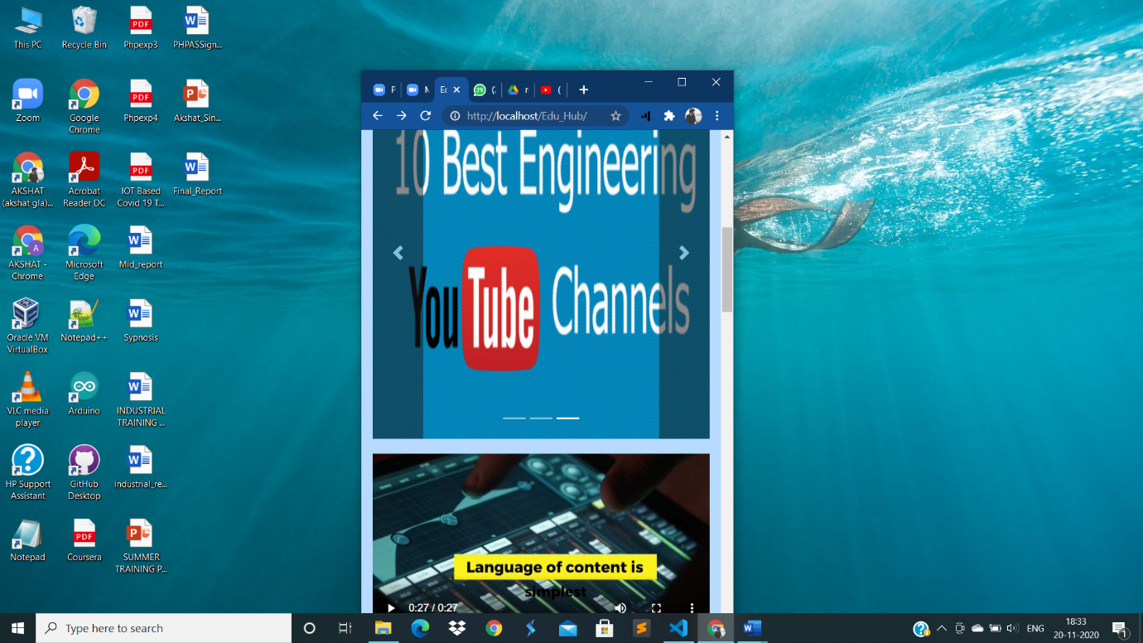

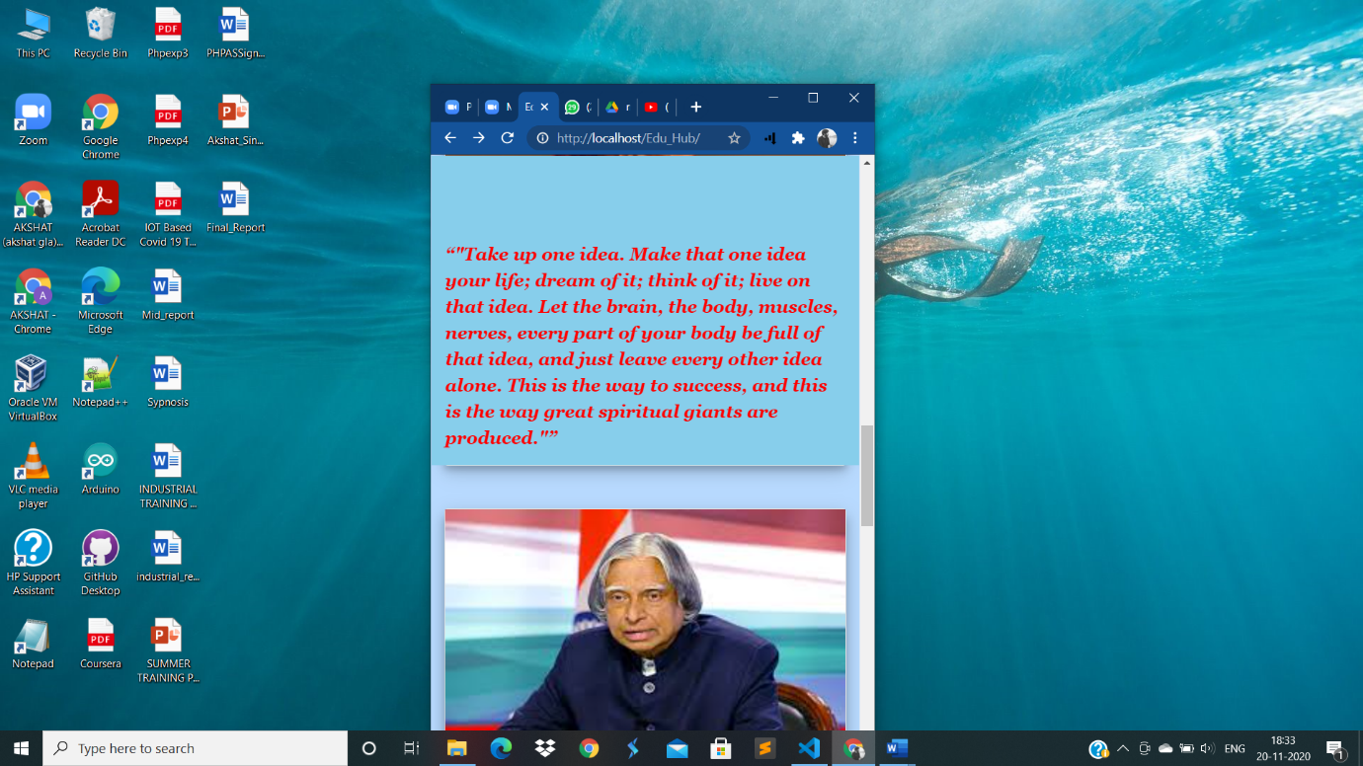

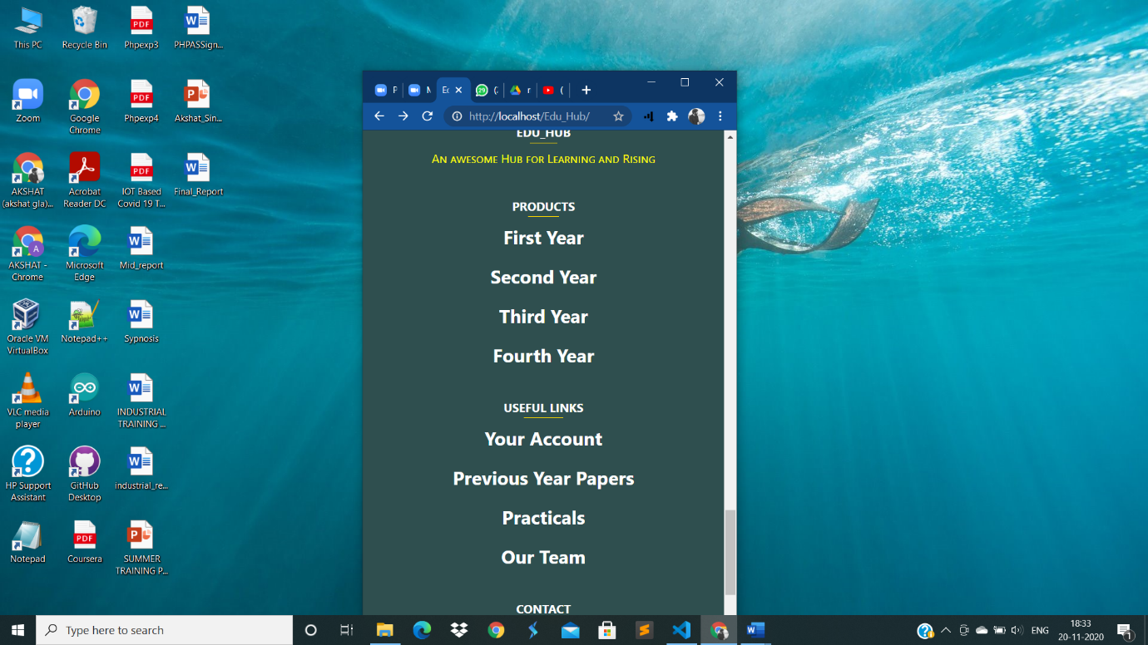

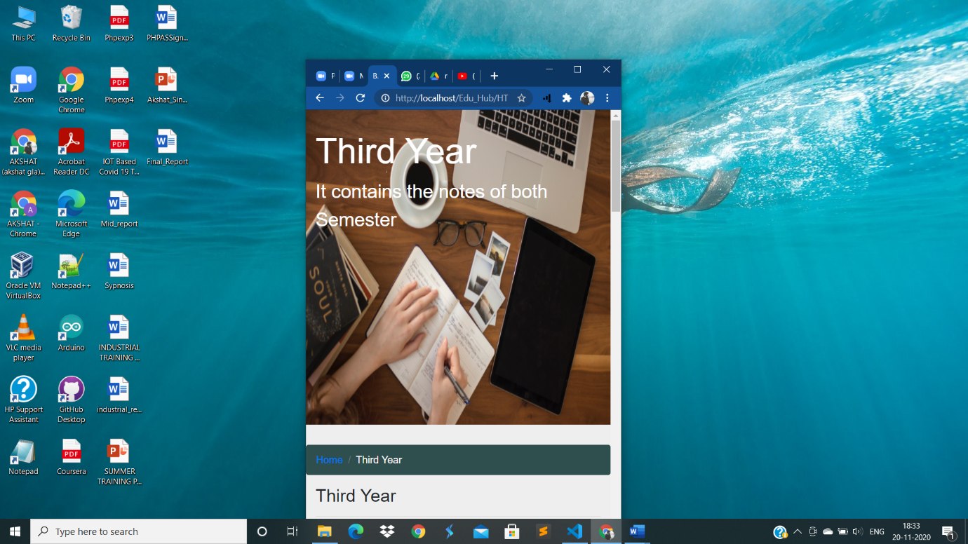

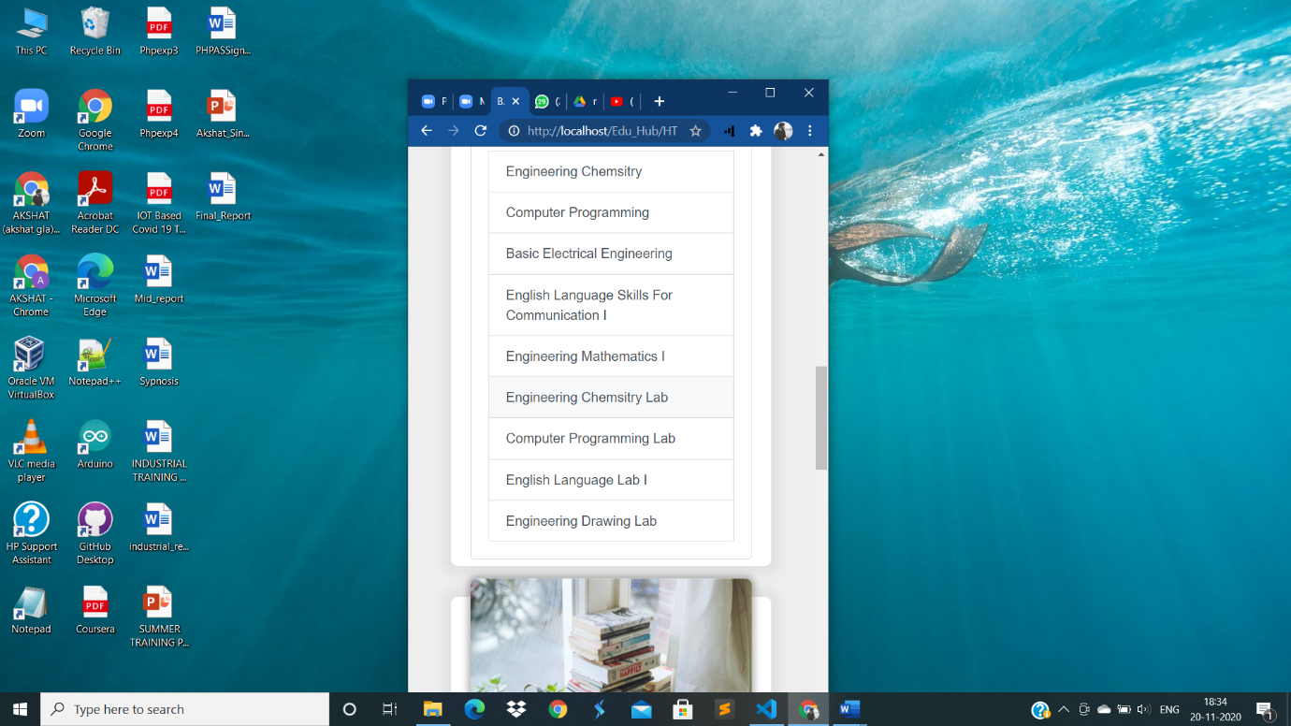

**5)References/Bibliography**

**1)** [**https://www.w3schools.com/**](https://www.w3schools.com/)

**2)** [**https://collegespace.in/**](https://collegespace.in/)

**3)** [**https://www.youtube.com/**](https://www.youtube.com/)